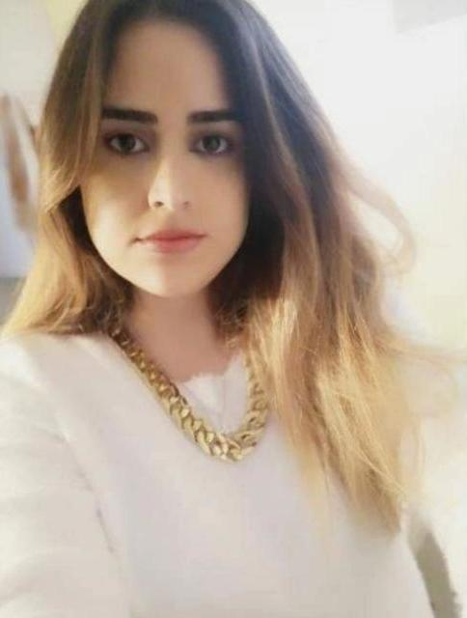
Mireille Sarkis Siwasilian
Mobile: +961 76 695049
Email: mireillesiwasilian@gmail.com

PERSONAL INFORMATION
Gender: Female
Date of Birth: May 9, 1992
Nationality: Lebanese
Address: Zalka, Lebanon
Marital Status: Single

EDUCATION
BA in Business Administration with Management
Arab Open University
BA- Graphics and Multimedia Design Technology- First Year- 2021
Arab Open University
Bac. In Socio-Economics
Kevork Harboyan High School

PROFESSIONAL EXPERIENCE
Cover Girl-Online Fashion Store
Founder-Management – Sales - Graphics
Sales Associate: Feb 2017 till Sept 2020
Basic Outlet Store – Antelias- Kaslik

Sales Associate: Toys for Less- Mtayleb Christmas Season Dec 2018- Jan 10 2019

Private Tutoring 2012- Present
Operations Assistant: Data Entry, Stock Control, Customer Service Mar 2014 – Mar 2015
Pharmacy DIANA, Zalka
Sales Representative Jun 2013 – Feb 2021
AVON Cosmetics, Beirut
Cashier and Customer service Nov 2012 – May 2015
MALAPCO - MALLAH SAL, Jal el Dib

TRAINING AND CERTIFICATION
Digital Marketing Certificate
Shaw Academy- Online Course
Training: Facial treatments, Laser Hair Removal, Cellulite, Skin tightening, Assistant, Data Entry,
Dream Body Spa, Zalka
Laser Hair Removal, The Laser Clinic, Zalka
Skin Care Course
Make Up Designory School (in association with YON-KA products, France)

COMPUTER SKILLS
Adobe Suits (Photoshop, Illustrator, InDesign)
Microsoft Office (Outlook, Word, Excel, PowerPoint)
POS system
Quickbooks Accounting Software – Basic Knowledge

LANGUAGES :
Arabic, English , Armenian, French

INTERESTS
Fashion, Beauty, Media, Graphics, Food, Music

