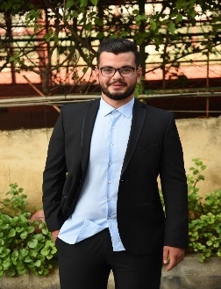
MOHAMAD ALI AHMAD AOUN
BEIRUT, HADATH · 76/715132
mohamadaliaoun066@gmail.com

I am a self motivated , Graduated from Lebanese International University (liu). I show a lot of interest and commitement in my field and I look forward to continue my educational career and pursue further degrees in the fields of business.
I show a valuable level of accuracy , the ability to concentrate for the smallest details and to work hard under excess pressure in addition to being able to work as a part of team . I always quest for knowledge, staring into the positive aspect of the future.

EXPERIENCE:

- Mobile phone and accessories store manager at Today’s Mobile
11/02/2020 – 01/2/2022
- Help customer select the right mobile device for their needs and also sell other telecommunication services.
- Help customers by omt.

- Supermarket cashier at Super Market Ansar
11/05/2019 – 09/12/2019
- Managing transactions with customers using cash registers.
- Scanning goods and ensuring pricing is accurate.
- Collecting payments whether in cash.

- Store supervisor at Aoun Library
10/04/2018 – 08/05/2019
- Overseeing salespeople, cashiers, shelf stockers, and other employees.
- Managing finances and preparing an annual budget.
- Keeping records of expenditure, sales figures, and employee performance.
- Evaluating the supply and availability of stocks, and profit-margins.

- Sales coordinator and Store Keeper at Dar Aoun
11/07/2016 – 08/04/2018
- Coordinating the sales team by managing schedules, filing important documents and communicating relevant information.
- Keep a record of sales and restock the store accordingly.
- Manage and train store staff.

EDUCATION:
- lebanese baccalaureate:Life Science {pursed in 2017}
At Students Paradise Secondary School{SPSS}.
- BSc:International business management.{graduated in 2022}.
Additional curriculum:
Practical accounting academy :
- Bird accounting software
- Junior Accountant

SKILLS:
- Computer skills: MICROSOFT WORD,EXCEL,POWERPOINT.
- Trading skills: TRADING VIEW,CRYPTO.

ACTIVITIES
- Interested in fields of business.
- Interested in seeking higher degrees in business management in the future {Master and PHD}.
- Interested in the beauty of the nature and relaxing music .
- Interested in learning foreign languages.

References are furnished upon request.

