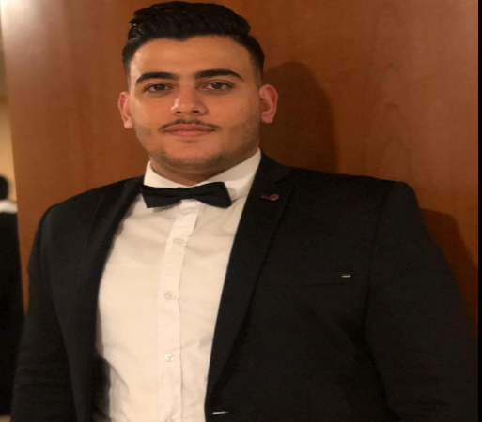
Phone:
+961 76025705

E-Mail:
ali.m.salah10@gmail.com

Linkedin:
https://www.linkedin.com/in/ali-salah-4721871a5

Soft skills
- communication
- team work
- problem-solving
- creativity
- time management
- leadership
- goal seeking
- attention to detail

Languages
Arabic-native
English-fluent

Technical skills
- Data analytics using Excel
- HTML/CSS
- Database management
- C#
- Developing ERP systems

Experience
6/2019-11/2020
Operator, Just Fajita Restaurant, Beirut
- Developed strategies with in coordination manager to provide better service.

Education
2019-2021
Bachelor’s Degree in Management Information Technology: Computer Information Systems – Management
Al-Maaref University
CGPA: 3.77

Certifications
Certificate:
- Data analytics for decision making/ Bon university
- Digital skills: artificial intelligence/ Accenture
- Cyber security/ Cisco networking academy

Internships
- E-volve company, working on CRM applications and EMR
- IDS company, working on different programming languages to enhance the technical skills (object-oriented projects).
- Banque du Liban, developing decision making process based on finance and economics.
ALI SALAH
System analyst and Web Developer. Well-versed in numerous programming languages including HTML5, C#, CSS, MySQL. Strong background in customer relations. High ability to build application, data base management and ERP systems.

