Amer Rabah  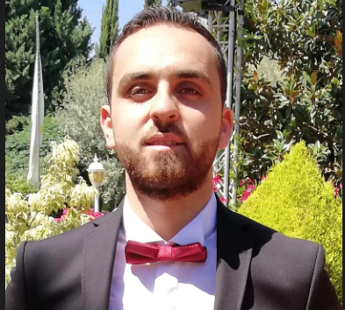  CONTACT  Address:  Houch Al Harima, West Bekaa, lebanon  Phone:  +96181761477  Email:  Amerhrabah@gmail.com  LANGUAGES  Fluent in English and Arabic |  | OBJECTIVE  Seeking a mechanical engineering position with your company where I can work and grow professionally.  WORK EXPERIENCE  Math And Physics Teacher  Iqraa association, Ghazza public high school  Ghazza, West Bekaa, Lebanon  July 2016 - September 2016  Maintenance Trainee  Daher International food (Poppins branch)  Mansoura, West Bekaa, Lebanon  August 2017 - October 2017  Maintenance Trainee  Toppack one co for trade and industry  Taanayel, Bekaa, Lebanon  October 2017 - January 2018  Car Maintenance And Scanner Trainee  Peugeot exclusive agent  Chtaura, Bekaa, Lebanon  October 2018 - November 2018  Production And Maintenance Foreman  Sicomo Powerplant (Waste To Energy)  Qabb Ilyas, Bekaa, Lebanon  November 2019 - till now  EDUCATION  Masters of science in mechanical engineering (M.S) :  Lebanese International University  Khiara, West Bekaa , Lebanon 2019  Thesis Statement in : HVAC, plumbing, sanitary, and firefighting calculations and design for a villa.  Bachelor of science in mechanical engineering (B.S) :  Lebanese international university  Khiara, West Bekaa, Lebanon 2017  ADDITIONAL SKILLS  - High pressure steam boiler and turbine (control and maintenance).  - Heat resistant materials, refractory works.  - Water treatment systems  - Pneumatic plus hydraulic systems  - Continuous emissions monitoring systems  - Team management  - Heat exchangers  - Revit workshop participation.  - Word-Excel-Net Beans-AutoCAD-Ansys-Mathematica-MATLAB.  REFERENCES  References available on request

