Pamela El Hoyek
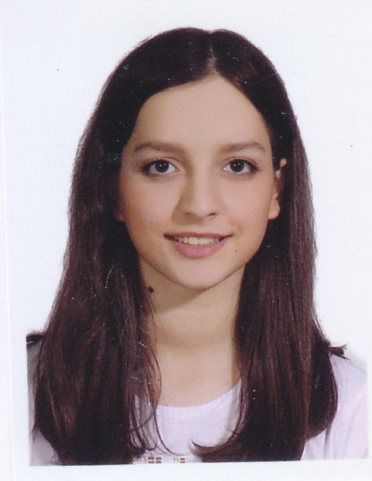

Personal Details

Name
Pamela El Hoyek

Email
pamelahoyek@yahoo.fr

Phone
+961 71085048

Birth date
9 February 2001
LinkedIn
Pamela El Hoyek

Languages
Arabic
French
English

Education
Bachelor of Accounting and Audit
Lebanese University, Achrafieh, Beirut Dec 2019 - end 2022
15.5/20
Bachelor of Management Information Systems
Lebanese University, Achrafieh, Beirut Dec 2019 - end 2023
16.22/20
French Baccalaureate: Economic and Social Sciences
Collège des Sœurs des Saints Cœurs, Sioufi 2019
with high honors
Experience
Accountant and Treasurer
Pharmacy Embassy, Achrafieh
27th July 2022 – 14th September 2022
- Bank reconciliation
- Supplier reconciliation
- Registering daily transactions
- Client account reconciliation
- Cash count
- Supplier payments

Part Time Junior accountant
Fernand Hosri Group Holding
21st September – present
- Accountant for 7express supermarket
- Setting retail prices on omega software
- Registering invoices on omega software
- Registering payments on Paragon software
- Replacement manager for the supermarket
- Supported new cashiers in their training
- Goods receiving and inspecting
Skills
Algorithmic Concepts
Programming Concepts
Object Oriented Programming (OOP)
Java
C++
Microsoft Excel
Microsoft Word
Microsoft PowerPoint
SQL
Database
Networking
Dataflow software
Softpharm software
Omega software

