Tarek shadi Zahalan  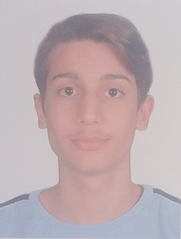 | Aley  76780918  zahalantarek@gmail.com

Objective
To secure employment with a reputable company, where I can develop my skills and knowledge.

Education

BS computer science student | Haigazian University

2020 – 2022
Finished Second year of computer science major
(president’s list) in Fall 2020
GPA
Major average. 82.22/100
Cumulative average 80.4/100

Lebanese baccalaureate |Life science 2000

2019 – 2020 - Grade 12
Education & Teaching Secondary School (ETSS) – Aley

2018 – 2019 - Grade 11
Education & Teaching Secondary School (ETSS) – Aley

2017 – 2018 - Grade 10
Lycée National School– Choueifat

Training course

CODING COURE | LOYAC (non-governmental organization - NGO)

2000
Completed an Introductory 3 months coding course at LOYAC- Achrafieh, Beirut

University courses
- Introduction to computing
- Computer programming
- Advanced computer programming & data structures
- Logic design of digital systems
- Design and analysis of algorithms
- Discrete structures
- Concepts of programming languages
- Computer architecture & assembly language
- Database systems
- Theory of computation
- Design and analysis of Object-oriented programming
- Introduction to data science
- Mobile application development
- Professional and Social Issues in Computing
- Calculus and Analytic Geometry III
- Differential Equations
- Linear Algebra
- Statistics

Skills

- Microsoft office
- computer programming and coding
- java, c#
- mobile applications android studio
- html , css and javascript
- Php backend web development /laravel
- Databases (mysql)

Activities
Reading, music, swimming and computer games

