Carla Mohammad Mhanna

Email:carlamhanna@hotmail.com
Mobile Number: +961 71553449
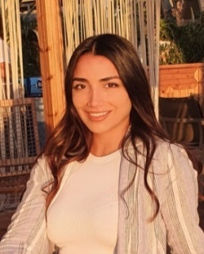
PERSONAL BACKGROUND
Name: Carla Mhanna
Date of Birth: February 9-1996
Address: Lebanon– Beirut, Hamra
Nationality: Lebanese
Marital Status: Single

OBJECTIVES
To secure a position in a well-established organization with a stable environment in which I can improve my skills.
Education
2014-2018: BT 1, 2, 3
Educational Arab Institute, Zkak el Blat
2018-2020: TS 1,2
Educational Arab Institute, Zkak el Blat

2020-2021: Graphic design
Lebanese International University, Beirut

Experience
2013 – 2016: Infomed International For Events
Hostess - Registration
2016 – 2017: SalonZac and Zoe, Verdun
Receptionist - Cashier
2017 – 2018: Salon Wael and Wajdi, Verdun
Manager
2018– 2019: Spinneys
Cashier
2019 – 2020: SERAY Restaurant
Hostess
2020 – 2022: Mira Casting Agency
Casting
Leila ABC Verdun
Hostess

Languages and Computer SKILLS
- English, Arabic, French
- Microsoft Word, Excel,PowerPoint, Internet
SKILLS
- Be Friendly but formal
- Listening
- Have the ability of taking decisions and responsibilities
- Solving problems and resolving issues
- Have the ability of a leadership
- Work under pressure
HOBBIES
Travel, Swimming
REFERENCES
References are available upon request.

