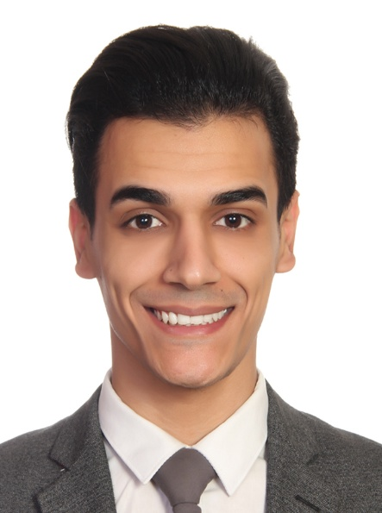

Mohammad kashany

Personal details
- Fullname: Mohammad Abbass Kashany
- Nationality: Lebanese (born in beirut, mount lebanon district)
- Address: lebanon , beirut
- Mobile: (+961)76525790
- Gmail: moekash6@gmail.com
- Height: 177cm
- Weight: 68 kg
• vaccination: Pfizer
Profile
My experience has led me increasingly to specialize in managing both my work and relation with multinational people , i also had the chance of applying some of the modern leadership methods(through staff motivation and involvement in decision-making and target-setting, clarity in communication, and easy personal interrelations). My own cosmopolitan background and analytical interests in other cultures , have also left me with confidence of handling negotiations that require the reconciliation of different national approaches

Skill base
- Proven leadership and human management skill
- Adaptability to problem solving and new locations
- Familiar of the artistic and commercial world , the governmental culture
- Languages: fluent in English (spoken and written) and arabic(native)
- IT: Excel, Microsoft, Windows

Education
- Lebanese international university 2015-2018
Studied marketing business management, and international business
- Had extra courses in costumer psychology
- High school graduate

Personal career
LAT 1st and business class lounge (Beirut international airport)
Team leader at the lounge my duties is to make sure all the passengers are relaxed and satisfied with the services
La petite maison beirut (chef de pass )
- Coordinating and managment of the front of the house staff team and service
- Handling any problem related to the customers in a professional way
- Coordinate the scedual of the staff and making sure that every one works respectively to it

Junkyard beirut ( waiter)
- Taking care of my personal customers making sure they are satisfied with our services
- Teaching new employees specially who are below my rank how to work and showing them the professional way of handling things

Cultural interests and physical recreation
- History, culture , music, psychology
- Working-out and football

