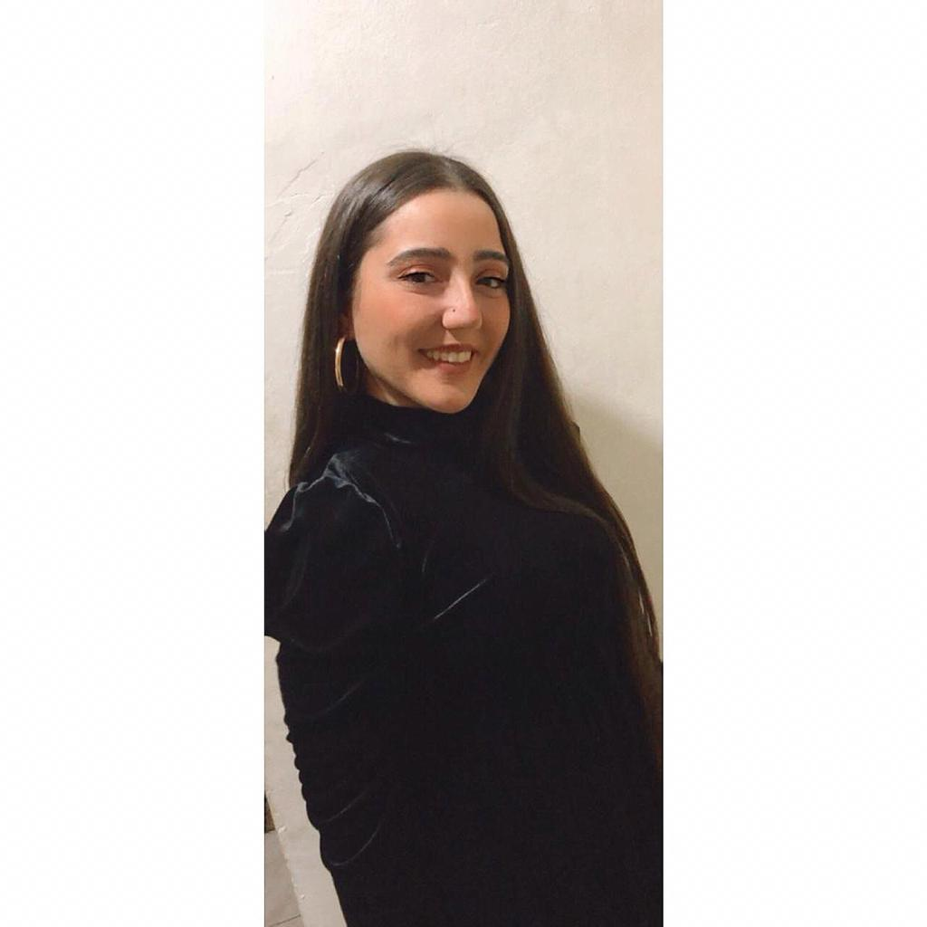  Profile  Diligent and responsible with excellent history of running smooth , good listening and communicating skills ,flexible with time , well organized and dedication to team success , and customer loyalty .  As far for teaching I am a multiple methodique user that fits with my class and students to accomplish and develop for them the love of the lesson , rich informations that could be used in and outside the class , and success in there education  OBJECTIVE  Seeking a mathematics teacher position in a respectful school which offers me the opportunity to develop new skills while strengthening those I already possess.  Contact  Nationality: Lebanese  Date of Birth: 13 May 1997  Marital Status: single  Amchit - Lebanon   +961 71996388  rozinamaziji@outlook.com  Hobbies  Swimming  Camping  Skiing  Sports |  | rozina mazgi  Mathematics & Science Education  EDUCATION  Pro Training center  2022  Certificate in accounting course  Lebanese University Faculty Of Pedagogie  2018-2021  Associate Of Science , Maths , Physique and Chemistry  Amchit Secondary School  2010 - 2018  Associate Of Science  SKILLS  Microsoft Word, Excel, PowerPoint, Omega POS, and Social Media.  LANGUAGES  Arabic: : Good , written and spoken  English: Good, written and spoken.  French: Good, written and spoken.

WORK EXPERIENCE

Malak al tawouk

Manager April 2022 – present
Cashier June 2021- March 2022
Tasks:

- Worked flexible schedule.
- Customer communication.
- Team work.
- Used the POS software to applying customers order, order the staff meal, and finally to cash back.
- Receive payments by cash, credit cards.
- Issue receipts, refunds, credits, or change due to customers.
- Replace a dispatcher place if needed, make sure the order is the same as the client order, make sure the order is never late.

Education Trainee at – zalka secondary school– Wardieh Amchit– College notre dame du mont carmel / Fanar –Lycee Amchit

November 2019 -2021
Tasks:
- Lesson observation, math and science.
- Prepare and submit weekly/monthly reports about the lessons observation.
- Feedbacks about the teacher’s method to improve myself.
- Preparing a lesson and teach a class for 3 years 3 times per cours.
- Preparing a presentation for each lesson with the test.
- Assist in the processing of test creation, and lesson for seeking better skills in my students.
- Assist with lesson projects.
- Receiving new technologique methods that help the student to gain the information in an easier way.

Edde sands resort
Cashier May 2019 – august 2019
Tasks:
- Worked flexible schedule and extra shifts for events, romantic dinners
- Customer communication
- Team work
- Learned to be ready at any section and position
- Used the POS software to : discount , put vouchers in , applying customers order to their room bill , and finally to cash back .
- Receive payments by cash, check, credit cards, or vouchers.
- Issue receipts, refunds, credits, or change due to customers.

supermarket jbeil – supermarket spynneys jbeil -
Sales 2017 - 2019
Tasks:
- Receiving feedbacks from customers.
- Negotiating the product in sale with the customers.
- Customer communication.
- Resolving customer complaints for not finding what they seek like the product in sale to complete the purchase.
- Reporting all the soled items in a day with the total.
- It was an on and off work because I was called for this position in the Christmas season mostly.

beauty base amchit
Sales 2018
Tasks:
- Warmly greet all guests upon arrival and departure.
- Fill profile for all deposit object of the guests with reservations.
- Escort guests through the shop to help them with their purchase.
- Receive payments by cash.
- Issue receipts, refunds, , or change due to customers.
- Resolving customer complaints for not finding what they seek for.

Kids animation – fun planet
2014
Tasks:
- Making a kid birthday more fun.
- Face painting designs choose by the kids.
- Planning for the activities that match the kids figure, and let them all join the activity.
- Wear costumes by the parents’ choice such as smurf, spider man and more.

REFERENCES
Beauty base : Mrs.Roula 71830302
Manale promorion : 81 824 162
Edde sands : Cashier Manager Mrs.Ptarick : 76 108 008
Kids animation : Mr. Rayanne 70388225
Maths Trainee by Dr.Haifa Al Asaad : 03 292 544
Science Trainee by Dr.Noha Saade : 70 512 703
Malek al tawouk : Elie Abdo : 70904878

