 |  |  | Abdul Rahman Mohamad Jandal Zoeby
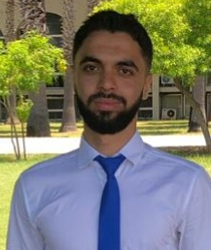
Contact  PHONE:  +961-78-820521  EMAIL:  aboydicell.16@gmail.com  Hobbies  Riding  reading  playing  football |  |  | EDUCATION  2018-2019: Lebanese baccalaureate in Socio Economic, Iman School, Tripoli, Abou Samra  2021-2022: Bachelor in information technology at Al Jinan University, Tripoli, Abou Samra  WORK EXPERIENCE  - March 2021- June 2021: registrator in the College of Arts and Humanities IN (JINAN UNIVERSITY )  - A member of mashghal al Jinan University  - 2022 data entry  - Training in the laser association (it support )  - One month in the company softwave Specialized in Customer Support.  - One month in the hospital orange nassau government billing department.  CERTIFICATES  Certificate of achievement pre-intermediate B (level 4)  LANGUAGES:  Arabic: native language  French: good  English: normal  COMPUTER SKILLS:  Java  Microsoft(word, excel, power point)  access  SQL (oracle, ssms)  html + css + Javascript  Console  visual studio ( c # ) (form application, console)  Photoshop  Adobe Illustrater  Mobile application (java, xml)

