Personal Statement
A motivated young man who continuously tries to expand and broaden his experience in different business realms. Despite financial circumstances that disrupted my educational pat, I was able to gain vast experience in recognized, leading companies in the accounting, finance, and sales departments.

Skill Highlights

- Professional Microsoft Excel use  - Professional Microsoft Excel use  - Strong decision maker | - Leadership and team building  - Efficient negotiation and communication  - Quota-surpassing sales

Experience
Accounting trainee and Sales Representative – 2016 to 2018
New Evan Lingerie, Beirut
- Cooperate in preparing balance sheets and income statements.
- Keep track of budgets and spending.
- Increase wholesale to local and international firms.
- Meet and exceed daily sales quota.

Senior Cashier and Sales Associate – 2018 to 2019
- Opening and closing registers.
- Training of new cashiers (total of 4 new employees)
- Constant random revision of customer satisfaction by quick verbal or electronic surveys to maintain a high-quality service and promote an exceptional shopping experience.

Education
- Bachelor in Economics and Sociology (2018).
- One-year Business Management at AUCE University.

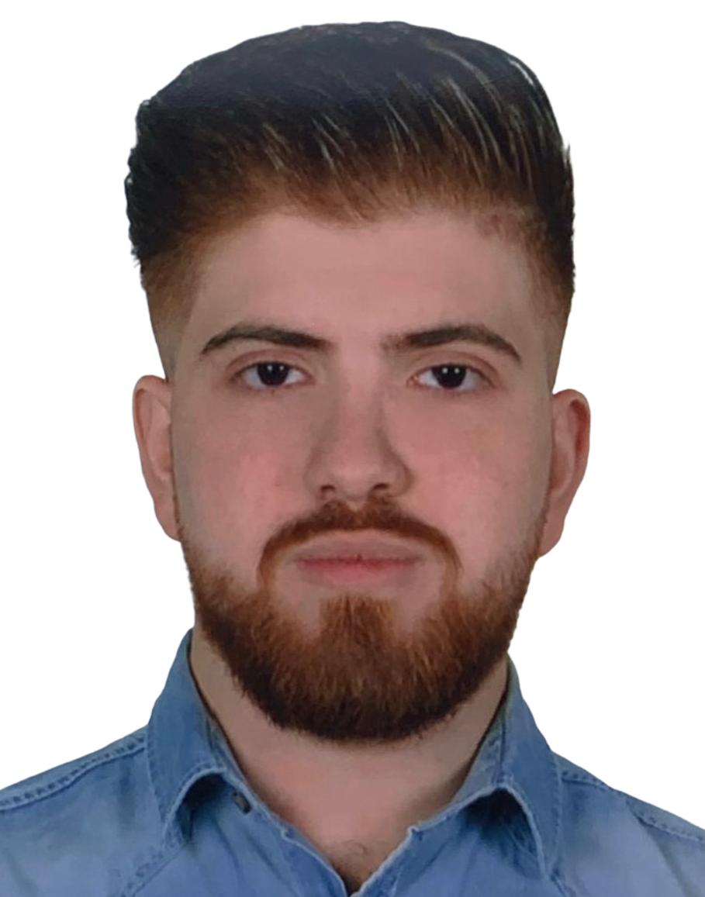
Mustafa Khalil

Contact
Address:
Beirut, Lebanon.

Phone:
+961 70 348 934

Email:
moekh777@gmail.com

Date of Birth:
14 March 2000

Languages
Arabic – Very Fluent
English – Very Fluent
French – Intermediate

