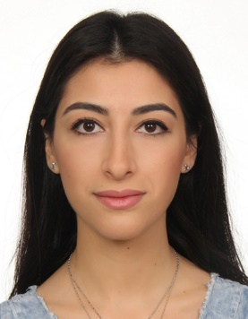
RESUME

Name: STEPHANIE SEUKUNIAN
Nationality: Lebanese
Date of birth: 29-09-1993
Marital status: Married
Adress : Jal el dib, assaad rachid street, harboyan bldg, Bloc D 5th floor
Phone: 00961 70 731617
E-mail : stephanie.seukunian@hotmail.com

Educational Background
2011-2014 Bachelor Degree in Businees and Manangement « Licence en Gestion et Management » –Saint Joseph University
Other certificates:
2016 Lebanese financial regulations by BDL
2018 Banking ethics by BDL

Internships:
July-August 2013 Internship at FRANSABANK bourj hamoud branch – operational and commercial section
June-July 2012 Internship at Société Boghos SAL – accounting section

Professional Experience
June 2017- present Teller at Fransabank SAL Antelias branch
October 2014-May 2017 Teller at Fransabank SAL Elyssar branch

Handling cash operations (deposit-withdrawal, foreign exchange…), executing money transfers, outgoing and incoming transfers and follow ups, depositing checks in account, issuing of banker checks, following up of unpaid checks, paying customer’s taxes. Recording all the issued checks and executed transfers and paid taxes during the day in the register and daily filing. Processing salary domiciliation operations. Paying electricity and other expenses of the branch with previous approval of the administrative department and filing them.

Skills and Qualifications

Organizational and Leadership Skills:
High sense of responsibility, work planning work, problem solving skills, ability to work under pressure, multi-tasking and analytical skills

Communication and Interpersonal Skills:
Customer focus, tactful and diplomatic,good listening, counseling, managing conflict, working well in teams.

Computer skills:
Banking software, Microsoft office programs (Word, Excel, Power Point, Access, Microsoft Project).

Language skills :
English – fluent
French – fluent
Arabic – fluent
Armenian – native language
Spanish - basics

Volunteering
July-August 2008-2010 Volunteering work with children at summer school – Oasis Mesrobian

