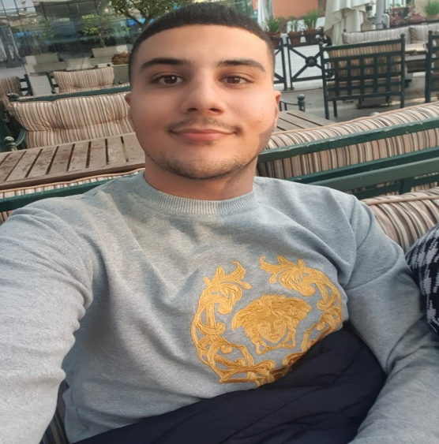
Hasan kobeissy

I am flexible, reliable and possess excellent time keeping skills. I am an enthusiastic, self-motivated, reliable, responsible and hard working person. I am a mature team worker and adaptable to all challenging situations. I am able to work well both in a team environment as well as using own initiative

Aramoun
Lebanon-Beirut
+96181671108
Email: haskobeisyy5@gmail.com

Skills
- Work under pressure
- Multi-tasking
- A desire to help people
- Excellent verbal communication skills
- Micro economics
- Macro economics
- Econometrics
- Analysis of the economy

Experience

April 2019 – July 2020
- Em sherif, Lebanon, Zeituna bay - Waiter
- Taking and serving orders
- Doing inventory

July 2020– June 2021
- Ni cafe, Lebanon, Verdun – Waiter
- Doing inventory
- Maintain day to day operation
- Taking and serving orders

June 2021 –
- Ni cafe, Lebanon, Verdun – captain waiter
- Assist head waiter
- Maintain day to day operation
- Opening and closing

June 2021 – Till now
- Ni cafe, Lebanon, Verdun – training team leader
- Organising shifts
- Cash closing
- Solving problems

Education
- 2005-2019
Le lycee National
- Bachelor degree
- 2019-2022
LAU (Lebanese American University)
Economics major

Languages
- English: fluent
- Arabic: fluent
- French: beginner
- Spanish: beginner

Awards
- Waiter Certificate – 2019
- Merry Course Certificate

