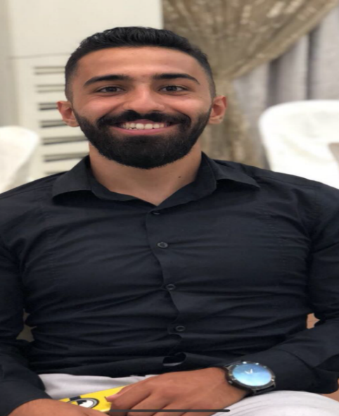 |  | EDUCATION
AMERICAN UNIVERSITY OF CULTURE AND EDUCATION
2014 - 2019
BACHELORS DEGREE in Management Information System

ANTONINE UNIVERSETY
MAY 2018–SEP 2018
COACHING AND STRENGTH DIPLOMA (LEVEL 3)

IBSPIRE FITNESS ACADEMY
2019
STUDYING LEVEL 4 (PERSONAL TRAINER )

mohamad ballout  Profile  An exceptionally professional and accomplished sales consultant with an impressive management information and communication skills. I am creative individual ,skilled in working cross-functionally to develop sales and marketing plans to engage prospects and bespoke solutions that repeatedly win business, I employ my naturally friendly and helpful persona ,engendering trust and going extra mile to assist all customers whom I support  CONTACT  PHONE:  961-71229761  Location:  BIERUT /HARET-HREIK  EMAIL:  mmdballout@gmail.com  DATE OF BIRTH :18/5/1996 |  | WORK EXPERIENCE
WAREHOUSE CONTROLLER ARAMEX/NEGERIA
MAY 2021 –NOV 2022
- Matching deliveries with dockets
- Load/unload vehicles including accurate completion of paperwork
- Sortation of orders and reporting of any damages

FITNESS INSTRUCTOR IN KX VERDUN
APRIL 2019- FEB2020
- Ensure the gym is clean and free of health and safety hazards
- Demonstrate the correct way to use exercise equipment
- Providing emergency first aid if necessary

FITNESS INSTRUCTOR IN PERFOMANCE FIRST
May 2018–DEC 2018
- Watch clients do exercises and show or tell them correct techniques to minimize injury and improve fitness
- Monitor clients’ progress and adapt programs as needed

SALES CONSULTANT at AZADEA GROUP
FEB 2017–JAN 2018
- Shipping and receiving a huge number of items
- Store the materials in the allotted places
- Ability to work under a high pressure

SALES CONSULTANT at AISHTI
April 2015–DEC 2016
- Provide excellent customer service
- Dealing with difficult people
- Achieve the daily, monthly and yearly target

SALES CONSULTANT at MIKE SPORT
Sep 2014–April 2015
- Having the ability to work accurately
- Merchandising the products
- Cash register and handling money
 |  | SKILLS

