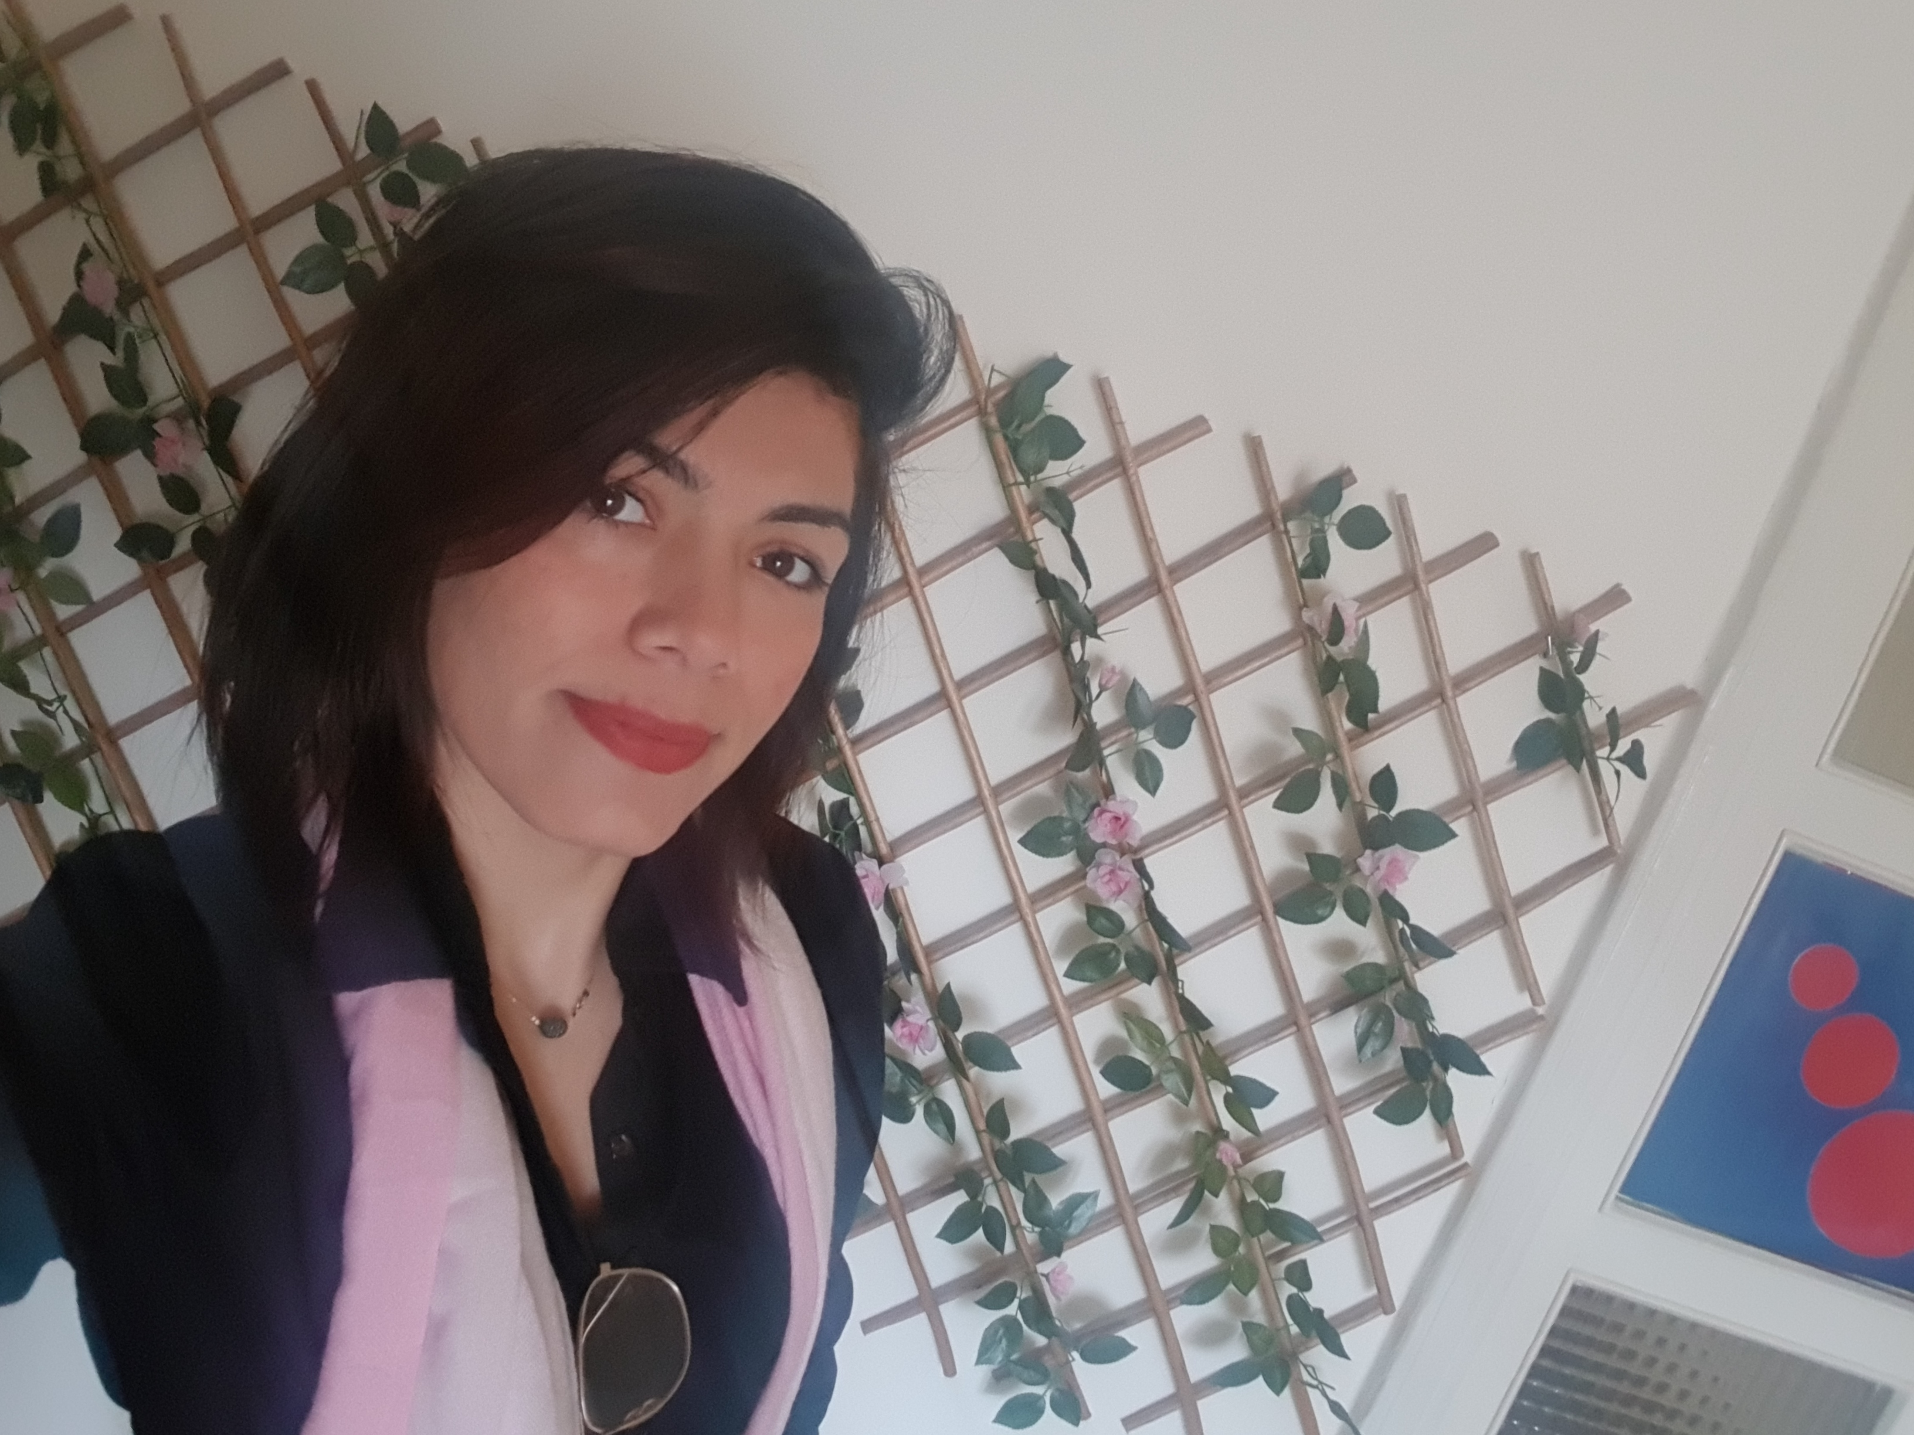
Rosette Nizar Mahfoud
Hamra
Rosettemahfoud@gmail.com

+961 - 71 904393

Personal Information:

Date of birth: 31/01/1995
Marital status: Single

Education:

>Completed Accounting and Finance I ACE (HAMRA)
>BACC II (College de la Charite)
>Fundamental of English (level 3) - American center Dbayeh
>GLS (Global Leadership Summit) - Attendance March 2019

Work Experience:

>Intern graphic designer at Horizons International 2021 - 2022
>Administration and junior accountant at Chemitech S.A.R.L 2020
>Telesales agent at Beirut Circle
>Administration at Cedar Taxi 2019
Data entry: cash in and out
Commissions and Customers Fees
>Junior Accountant at UPO 2018
Data entry: payables, receivables, invoicing.
Reconciliation: banks and suppliers.
Treasurer: cash in and out, checks in and out.

>Hostess and Sales representative (Part time)

>Cashier at Wooden Bakery 2017
>Assistant manager, costumer service at trust supermarket 2016 - 2017

Skills:

>Orange Software for Accounting
>Knowledge in the core Adobe programs: Photoshop, Illustrator, InDesign
>Familiar with Excel and Microsoft Word
>Languages: Arabic, English, French, Italian (beginner)

References are available upon request.

