Christian Daher
Jal El Dib · 70 849994
cmd10011@students.aust.edu.lb
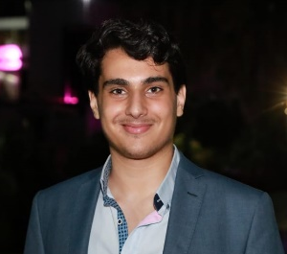
Birthday: 23rd of December 2002
Additional nationalities: Canada

JOB experience

JUNE 6, 2021 – november 6, 2021

Mezcaleria aishti, bartender.
- Multitasking
- Work under pressure
- Customer service

AUGUST 1, 2022 – UNTIL NOW

TOMORROW SERVICES, INTERN.
- Full Stack Web Developer
- Vue.js for frontend (html/css/js)
- Laravel for backend (php)
- Source Control (git/github/bitbucket)

Education

2020

HIGHSCHOOL, General science, val pere jacques
- Graduated with a GPA of 15.5/20
- Participated in MOS exams
- Participated in Robotics competitions

2024

Computer science, aust ashrafieh
- GPA 3.7+ in general, GPA 3.9+ on core courses
- Graduating in 2024

skills
- Microsoft office  - Problem Solving  - Passionate / Competitive  - Java / JavaScript(Node.js)  - Android studio / XML | - Working under pressure  - Attention to details  - Source control  - SQL  - HTML/CSS

Activities
I spend my time tinkering with computers, reading articles about the latest tech discoveries, and playing chess. In group projects I usually divide the tasks on everyone and get the work going. I’m working on getting to the top of my class. I can speak English, Arabic and French fluently.

I think I’m competent enough to now join the work environment that my major offers. I can catch up to any programming language needed in the workplace. I’m familiar with software engineering, networking, agile methodologies, data structures/algorithms, and OOP.

Additional hobbieS
- Reading
- Skiing
- Futsal
- Drawing
- Chess
- Solving coding challenges (Hackerrank / leetcode)

