Contact
Address:
Khaldeh, Arab Street, Mount-Lebanon

Nationality:
American, lebanese

Phone:
+(961)81-857544

Email:
mohamedomei@hotmail.com

LinkedIn:
linkedin.com/Mohamed Ali Omeiry

Languages
French – Native
Arabic – Fluent
English – Fluent
Spanish – Lv2

Hobbies
- Content creation
- Blogging
- Social media
- Gaming

Summary
Creative thinker, well informed with Marketing products, Advertising and Social Media. Strong background in project management and public relations.

Skill Highlights
- Project management  - Decision maker  - Interpersonal skills  - Teamwork | - Social media  - Innovative  - Fast Learner  - Ability to work under pressure

Experience
Marketing field - 07/2018 to 07/2019- Alumrex, China.
- Conducted market research to understand customer needs and preferences.
- Developed and implemented marketing strategies to achieve business objectives.
- Created marketing materials such as brochures, flyers, and email campaigns.
- Managed social media accounts and created engaging content to increase brand awareness.
- Maintained consistent brand messaging across all marketing channels.
Sales Trainee – 05/2022 to 07/ 2022- Bazaars company, Dbayeh.
- Developed Instagram campaign spanning 3 months, with fans participating in a social media game and reposting campaign images for a chance to win.
- Conducting desktop research, and gathering information through surveys by speaking to clients and staff.

- Liaising with clients, vendors, and suppliers accompanying the company sales executive.

- Telesales, contacting targeted clients.

- Updating documents and sales records.

- Observing and carrying out sales processes.

- Identifying potential weaknesses and offering improvement suggestions.

Owner of an online shop : “Myway.lb”

Education
Majored in Business Administration- Recently Graduated – Pursuing my master’s in digital marketing.
Currently enrolled at Saint Joseph University, BEI

Computer Skills
Email,Microsoft Word, Excel, PowerPoint, Adobe Photoshop.
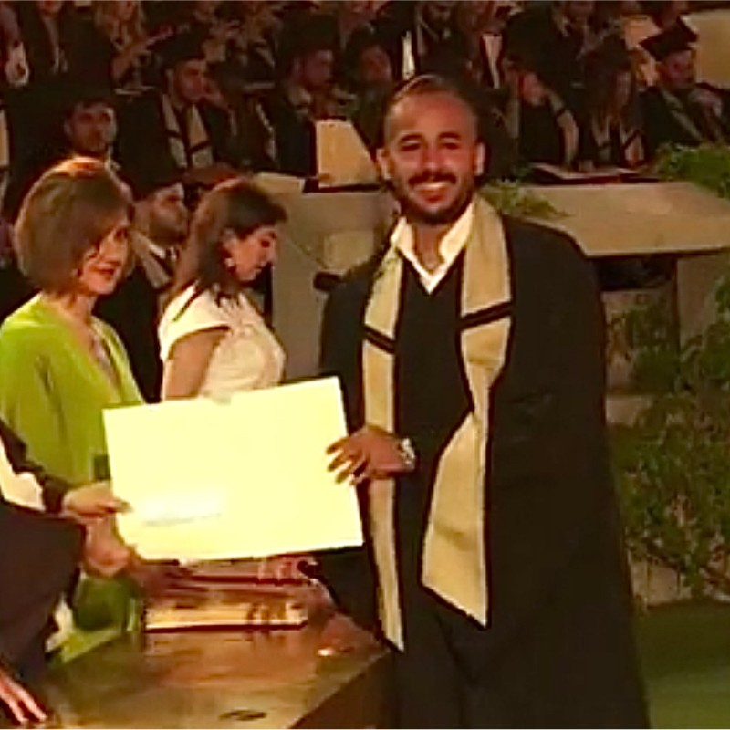
Mohamed Ali Omeiry

