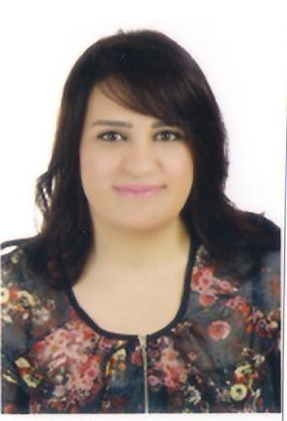

Nihal saad
Engineer Hussein A. Saad building
-Dalhoun El-Chouf, Lebanon
-Beirut, Lebanon
•telephone: 70046504e-mail: Nihal.saad@hotmail.com

Personal information

Date of Birth: 7 August 1991
Gender: Female
Marital status: Single
Nationality: Lebanese
Driving License: Yes

OBJECTIVE

Seeking a position in biomedical engineering where I can utilize my well-built analytical and communication skills to contribute to the progress of the firm.

EDUCATION

1994-2005 Al Manhal School Mazboud El-Chouf, Lebanon

2005-2009 Beit El-Hekme High School Daraya El-Chouf,Lebanon

2009-2013 Rafik Hariri University Mecherf, Lebanon
Degree: Bachelor of Science
Major : Electronics Engineering-Bioinstrumentation(Biomedical Engineering)

2013-2015 Rafik Hariri University Mechref,Lebanon
Degree: Masterof Science
Major : Electronics Engineering-Bioinstrumentation(Biomedical Engineering)
2018-2021Lebanese International University Beirut,Lebanon
Degree: Masterof Business Administration
Major: Finance

RELATED COURSES

Biomedical engineering major:
- Biomedical sensor
- Biomedical instrumentation design
- Biomedical engineering design
Biomedical engineering design lab
- Advanced biomedical instrumentation
- Technical English
- Medical imaging
- Electronics
- Control system
- Advanced therapeutic devices (Master course)
- Advanced medical imaging (Master course)

MBA in Finance:
- Accounting for managers
- Economics for managers
- Human resources
- Corporate finance
- Marketing management
- Business research
- Investments and Portfolio Management

WORK EXPERIENCE:

April 2019- April 2023: Lebanese army

Responsible for:

- Distribute medical devices to all military medical centers all over Lebanon, and provide their departments with appropriate and advanced medical equipment.
- In contact with known companies to deliver the right devices based on specifications and description.

- Build good relations with managers and engineers working as biomedical engineers inside these companies.
- Communicate with competitors to reach the appropriate and desired offer from one company.

INTERNSHIP:

- Worked at Dalla’a General Hospital for 2 months in Saida(July and August 2012)
Responsible of all administrative work related to medical equipment. Train physicians and nurses in machine use.

- Insurance knowledge.

RESEARCHES:

Publication of a paper “Feasibility study for Magneto Hydrodynamics hardware model”

SOCITIES JOINED:

A member of the Biotech Society at Rafik Hariri University

COMPUTER AND SOFTWARE SKILLS:

- Office program( Microsoft word ,excel, PowerPoint)
- Programming visual studio (program of C++)
- Matlab
- Internet

PERSONAL SKILLS

- Able to identify , analyze and solve problems
- Good oral and written communication skills
- precise and organized
- Able to work as a part of a team
- Work under pressure
- Self confidence

LANGUAGES

- Arabic - native language
- English –very good, spoken and written
- French – very good, spoken and written

HOBBIES

- Jogging
- Basketball
- Hiking

REFERENCES

Available upon request.

