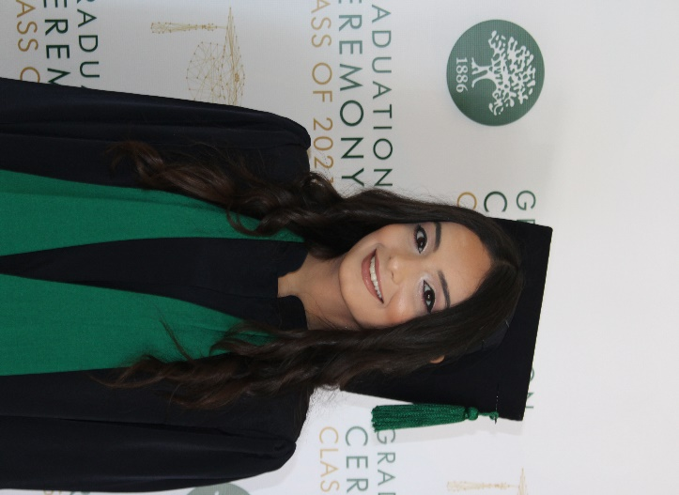
Selena Hsheimi
Beirut, Lebanon
+961 81745522
Swh11@mail.aub.edu

▼ Objective
I am a hard working computer science student with a passion for learning and applying various programming languages. I aim to acquire as much knowledge as possible in this field since it’s my passion. I’m currently striving to learn as many programming languages as possible because It thrills me to be able to program in many languages. I aim to combine my technical skills with my administrative experience to contribute effectively to projects and teams.

▼ Experience
July 2021–End of August 2021
Secretary & Medical assistant• Gynecologist clinic
I have been asked to schedule appointments for patients (phone operator), as well as checking blood pressure, help addressing wounds , help explaining to patients how to take their medicine if confused.

▼ Education
International school of Choueifat, koura
- I’ve graduated High school with Honors as well as a leader in the student life organization.
- I have been asked to perform (as a vocalist) in many theatrical plays in High school.
American University of Beirut, Beirut
- I am a computer science student pursuing a double minor in physics and math.
- I have worked on a Calculator project that involved GUI.
- I have worked on a game project that simulates a game of three levels (easy, medium, and hard) of human against robot.
- I have developed a Mental Health application project with a team of 5 people.
- I have created a database for NGOs with a team of 3 people.
- I have created my own small scale network.
- I have joined the robotics club which has enhanced my knowledge on working with Arduino.

▼ Skills
Programming languages:
-Java
-C/C++
-Python
I am familiar with:
-Object oriented programming
-Data structures
-SQL
-SML(Standard machine learning)
-React
-Computer Networking
-familiar with Agile

