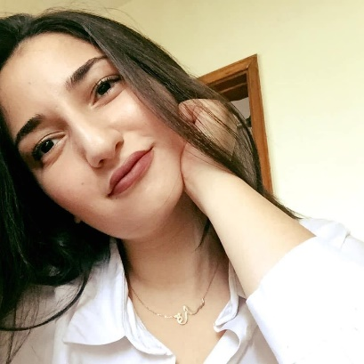 |  |  | Sara SLaibeh  management i hostessig i sales|Brand ambassadorship
Objective |  |  | Experience
A Lebanese University Graduate with a bachelor’s degree in Business Management.  Having a solid experience prior to my graduation for almost four years in the sales field. Always on the look for new opportunities that would provide me with personal and professional growth, and allow me to learn, and further develop my interpersonal, technical, analytical, and business skills. |  |  | Sales Associate • Parfois • March 2022 • March 2023  - Greeting customers with a smile.  - Provide professional support for customers to find their wants and needs.  - Supporting team members to push the sales.  - Replanchment, Spot check, checking alarms, cash control, checking and sending emails are daily tasks done in the store.  - Transfer items to other branches.  - UPT metric is measured daily.  - Handling operations reports to upper management.  - Receiving shipments with the store manager.  - Visual Merchandising with theme or color coordination.  - Stock management is a must after every shipment with the store manager’s supervision.  sales represenative • everythink sal • august 2021 • january 2022  - Greet Customers.  - Keep track of Inventory.  - Pushing sales by bringing customers together and create happy moments. (Signature method)  - Learn Board games and explain it to customers.  - Planning and building displays that maximize sales revenues on day-to-day basis.  - Leverage Interactive Experiences.  Sales staff • Mobile outfiters lebanon • march 2021 • August 2021  - Promoting new worldwide screen protectors.  - Installing clear-coat protection and fusion protectors on the spot.  - Elevate customer complaints to operations.  - Provide customers with information about mobile outfitters services.  Diffa group • promoter • march 2019 • august 2021  - Demonstrating features of a specified product to an audience or client.  - Assist customers in finding the suitable product they are looking for.  - Provide advice and guidance on product selection to customers.  - Disseminate product samples, brochures, flyers, etc.  - Engage with customers and discover their wants and needs.  - Submit daily sales reports to upper management.
Skills |  |  | Education
Excellent writing and communication skills, with an emphasis in organizational skills, teamwork, customer service and multi-tasker.  Extensive knowledge in fashion buying/styling and trends with strong attention to details, and the ability to analyze information.  English and Arabic Fluent speaker, Fair French.  Computer proficiency in Microsoft Excel, Word, Power point. |  |  | Bachelor’s Degree• MArch 2023 •Business Management  Attained Thesis under the title “The Impact of Emotional Intelligence on work team cohesiveness and performance” with honors “Very Good” graded.  Lebanese Baccalaureate • july 2017 •Makassed ali ben abi taleb college  Majored Economics and Sociology
 |  |  | licenses and certifications
Goal Setting Strategies- April 2020- Webanon.

Company Program - March 2019- INJAZ Lebanon.

Arts Fair- May 2016 – Makassed- 2nd place winner.

Financial Literacy - March 2015 – Bank Audi.
Slaibehs@gmail.com | +96176748015

saraslaibeh@icloud.com

