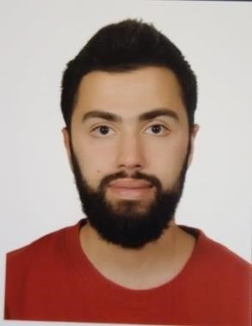 OMAR AYMAN FHAYLI
Phone Number: +96171817843
Email: omarfhaily@gmail.com
Address: Qalamoun Sea-Road Near Al-Faysal Restaurant
Personal Information:
Nationality: Lebanese
Marital Status: Single
Education:
2020 LT (Ahmad Akram Awaida Institute) Programming EL-Mina /Lebanon
2019 TS2(Ahmad Akram Awaida Institute) Administrative informatics ELMina/Lebanon
2017 BT3 (High school degree) (Qalamoun Institute) Accounting and Informatics
AL-Qalamoun /Lebanon

Work Experience:
- Accountant at Ozer (Clothes Store) between Jan 2014 — Mars 2016.
- Accountant at Dar Al-Amar Restaurant between June-2017 — August-8-2018.
- I worked on different programming projects (freelancer) with different languages since 2019 till now.
- I worked as private teacher for computer sciences students since 2020 till now.
Languages:
Arabic – French – English
Skills:
Microsoft programs: Word- Excel - Power point.
web (HTML, CSS, JAVA SCRIPT, PHP) WordPress (Elementor) –Java – C++ - Database (Microsoft Access, MySQL) – Vb.net.

