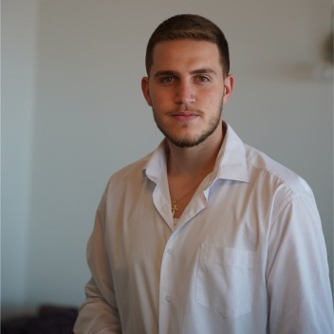
KARL CHAMOUN RESUME

Personal Information

  - Name: Karl Marwan Chamoun
  - Date of Birth:September 29th , 2003
  - Nationality: Lebanese
  - Social Status: Single
  - Home Address: Tilal Ain Saadeh, residence al Mada 1, block F , 2nd floor
  - Home Tel: +961 01900230
  - Mobile: +961 76337137
  - Email: karlchamoum123@gmail.com or karlchamoun123@icloud.com

Objective

  - University student seeking to work in an environment that challenges me to improve and constantly thrive for perfection in all the tasks allotted to me and achieve high career growth through a continuous process of learning for achieving goal & keeping myself dynamic in the changing scenario to become a successful professional and leading to best opportunity.

Educational Background

- Bachelor degree inGeneral Busines:University la Sagesse: 2021-present

- Bac 2 in economics and social studies: College De La Sagesse Achrafieh (2005-2021)

- DELF “TCF” (2020)

Internship & Experience

- JUNE 2023 – PRESENT: Junior Accountant at Mozart Chahine
- May – July 2022: Cashier at Number One the club

- January- february 2022: Cashier at Le Charcutier Aoun

- August 2020 – January 2022: Team Leader at Mrad Company : company responsible to assure any kinds of caravans and catering vans to any shooting sets .Where ads and televisions series and films are filmed

- July – August 2019: cashier at GT Karting

- July – August 2018: waiter at sroud aa broud Jiwar el Hawz

Technical Skills

- General Accounting: Balance Sheet, Journal, Balance, T Account , analyze financial data and generate financial reports

- Data entry: using (P.M.S AND V DOLPHIN )

- Other: Microsoft Office (Excel, Word, PowerPoint, Access)

Personal Skills

- Trilingual: Arabic, English &French
- Good communicator
- Organized, disciplined
- fast learner
- motivated
- problem solver
- perseverant
- creative
- adaptable
- easygoing
- optimist and respectable.
- Well managed skills
- Analytical skills

2

Extra-curricular activities

  - Past member of Scout du liban

  - Vice president of “Fersen Jwar el Hawz” -

  - Darbuka player

