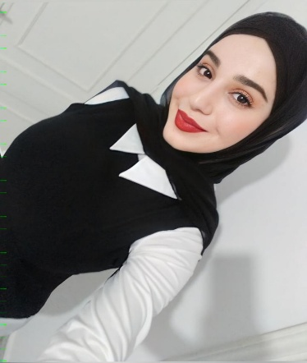
May Bazzi
21 YO |Beirut | 70389451 | maybazzi8@gmail.com|

Objective

Experienced Telesales Agent with excellent communication, problem-solving, coaching, and leadership skills, ensuring efficient customer experience and setting performance goals to meet sales targets and quality assurance standards.

Experience
- Citruss TV ( present)
Outbound Telesales
- Make outbound calls for promotions, special pricing; actively convert calls into sales through predictive dialers and manual dialing

- Using coaching, training sessions, and one-to-one meetings positively to take ownership of your development

- Making outbound lead follow-up calls to potential and existing customers by phone qualifying leads and selling products and services

- Compiling and working lists of prospective customers for use as sales leads, based on information from websites and other sources

Basque Gateaux et dessert (2021/2022)
Sales Consultant
- Cultivate relationships with new customers to achieve sales objectives and provide insight into new products, features, and options. (Wedding Plans/ Birthday’s event)
- Strategically negotiate with customers to close on deals and increase sales.
- Maintain contact with customers via email, phone calls, texts, and regular updates on promotional offers.

Education
B.A English literature/Linguistics (2023)

Awards and Acknowledgements
- Hultprize business school certificate for social enterprise
- Centre mine on Campus team Winner for business ideas/branding

