Taha AL Jaouni
Lebanon, Beirut · 76030469
Email: tahajaouni7@gmail.com

Skills
- Communication Skills.
- Leadership skills.
- Time Management.
- Fast Learner.
- Microsoft Office.
- Computer Skills.
- Ability to Work under Pressure.
- Ability to Work in a Team.
- Google features.
- Multitasking.
- Ability to work/learn online.
- Adapted with
Programming apps.

Professional Summary
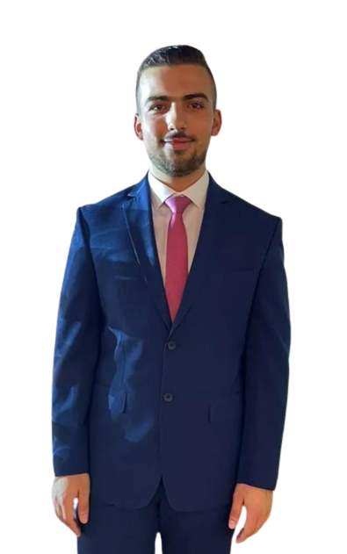

Ambitious and driven computer science student at AUL, Lebanon.

GPA of 3.5, demonstrating academic excellence and commitment.

Proficient in Java, C++, and SQL, Html, Css, Java Scrript, php, mysqli, with a strong foundation in

programming languages. Possess strong problem-solving skills and

acute attention to detail. Coursework in machine architecture,

assembly language, and logic design, providing a solid

understanding of computer systems and digital circuits. Readiness to tackle new challenges and offer innovative solutions.

Eager to contribute to the dynamic and ever-evolving field of technology.

Experience

December 1, 2021 – March 1, 2022

IT support
Technical Support in Jiatech.

March 12, 2022 – January 25, 2023.

customer care
Customer Care Representative in Glisten and Gleam Jewelry online store.

Education

Started: Aug, 2021

Bachelor, Arts, Sciences and TechnologY University in Lebanon, Beirut.
Through my studies, I have gained knowledge and skills in various areas of computer science. I have completed courses in networking, logic design, machine architecture, programming languages like Java and C++, Html, Css, Java Scrript, php, mysqli and database concepts. I am proficient in designing and managing databases, writing code, and implementing algorithms, and creating websites. With a solid foundation in these areas, I am equipped to excel in roles related to software development, network administration, and database management.

