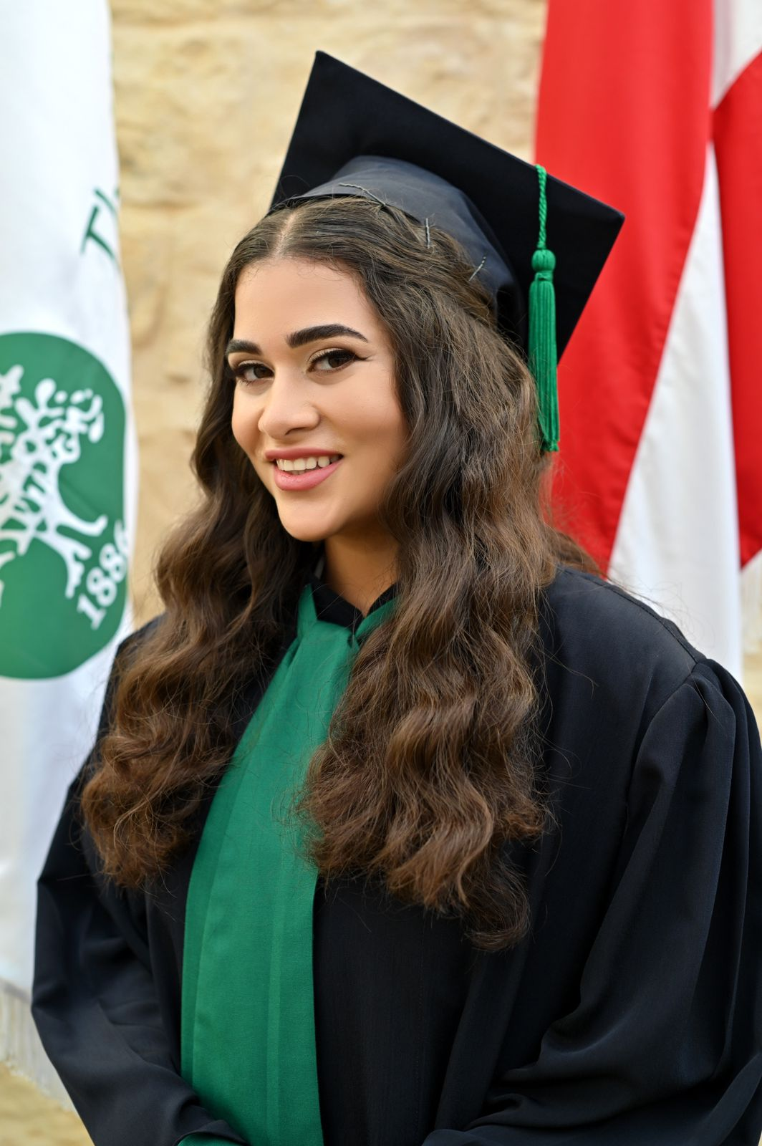  - Address:  Beirut, Lebanon  COMPUTER SKILLS  - Microsoft Office (Word, Excel, PowerPoint)  - Programming Languages: C,  C ++, Java, Standard ML, HTML, Assembly, CSS, JavaScript (Basic Skills)  SOFT SKILLS  - Problem Solving  - Leadership  - Adaptability  - Data Structures and Algorithms  - Database Management  - Discrete Mathematics  LANGUAGES  - English (Fluent)  - Arabic (Fluent)  - French (Basic Knowledge) |  | Yasmin Halabi  +961-81-986939 | yasminhalabi937@gmail.com  EDUCATION  American University of Beirut (AUB) Beirut, Lebanon  BS in Computer Science Aug 2022- Present  Cumulative GPA: 2.95/4.0  International School of Choueifat (ISC) Choueifat, Lebanon  Lebanese Baccalaureate Life Science: Official in 2022 Sept 2007- Jun 2022  UNIVERSITY PROJECTS  Spell Master Game  Software Construction Course – CMPS 270  - Designing a dynamic two-player word-building experience where players alternate selecting words, initiating each choice with the last letter of the opponent's word.  - Enabling a dynamic solo experience by introducing a bot function as the second player with three difficulty levels – easy, medium, and hard.  - Utilizing Charmaps and sets, where each index maps to a set containing words starting with that character.  Courtify  Software Engineering – CMPS 271  - Developing a Court Reservation App that efficiently streamlines bookings for sports enthusiasts by integrating player volunteering.  - Crafting the app’s interface as the Front-End Developer by including key features like efficient user registration, booking pattern tracking, and team formation for incomplete teams.  Euro Cup  Database Systems – CMPS 244  - Leading the development of a Euro Cup Database Management System, identifying entities, attributes, and constraints involved.  - Capturing data related to UEFA Euro Cup events, using SQL, to be used by soccer enthusiasts, statisticians, organizers, and advertisers.  EXTRACURRICULAR ACTIVITIES  - Member of the Computer Science Student Society at AUB  - Member of the AUB SETA Club (Students for the Ethical Treatment of Animals)  - Monitor at Sabis Summer Day Camp for 2 Years  - Member of the Folk Dance Group for 5 Years at Sabis  - Member of the School Varsity Basketball Team for 4 Years

