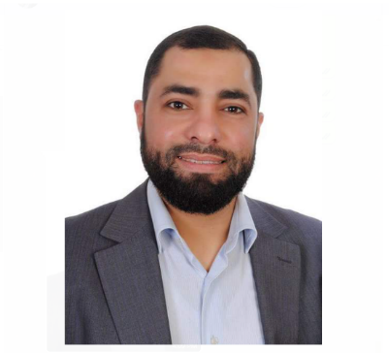



- Technical expertise
- Leadership
- Problem-solving
- Communication
- Planning and organization

CONTACT
As a highly experienced maintenance supervisor, I am enthusiastic about applying my expertise in electricity, electro-mechanical systems, low-current systems, and generators to elevate the performance and efficiency of the team I will be leading.

PROFILE
Mohideen Antar
FromSept., 1996 till May,1999 – Technician
Responsible for installing internal and external telephone networks and centrals and electrical installations
moh.antar.1976@gmail.com
General Technician
General Technician
Working as a general contractor and Maintenance work/2013-Present
Electricity, electro-mechanical Systems CC T.V. system, ducting HVAC System, and Earth and Lightening Systems ,Solar Systems
Freelancer
The Lebanese Company for the development and Reconstruction of Central District,S.A.L
Solidere)
Operation and Maintenance Supervisor/2009-2013
Park View Reality ,Burtous Building, Saifi 2

Pro-Central Maintenance Company related to Solidere Company
Beirut
General Technician/2001-2008

Capelec Liban
(Saifi Residential Project)
Beirut
Working as a general contractor and Maintenance
/2000-2001
Electricity, electro-mechanical Systems CC T.V. system, ducting HVAC System, and Earth and Lightening Systems ,Solar Systems

- Bathish and Aoun Company
- Mrs.Rachid Sabbagh al Majzoub Company
Saida

EXPERIENCE
High Technical School
Saida
1992-1996
.BT (Technical Baccalaureate) Electronics
2000-2004
Arabic Language
Dawa College and Institution Beirut

EDUCATION
70815620
Lebanon,Saida
2024
High School
Free Admission
Saida

Skills

