SALLY KAHIL
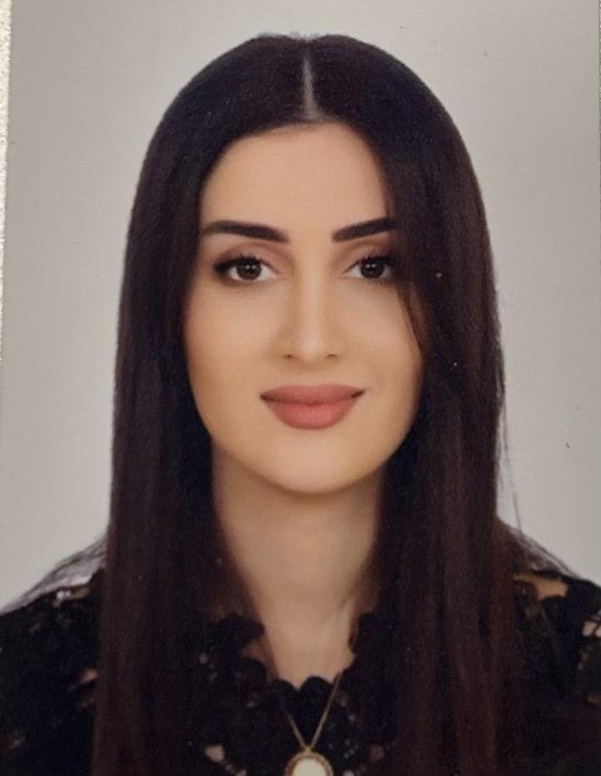
Lebanese| Nabatieh, Lebanon |+961 76 69 09 14 | sallyka7il@gmail.com

Experience
Freelance web app | ( 2020- 2024)
- developing front-end and back-end web applications and web services
- using asp.net – SQL - MySQL - html – CSS and many other specifications

BrightChamps | ( 2023 -2024)
- brightchamps is a global live-learning edtech platform for kids from 6 to 16 years to learn next-gen life skills such as Coding, Financial Literacy, Communication Skills and Robotics
- teaching coding
- teaching python , Artificial Intelligence , scratch ,thinkable,java, and html
- traveling the word by teaching student from different countries in USA & Canada and sharing knowledge with them

معهد اللآفاق -النبطية| (November 2019- June 2023)
- teaching Operating System for windows 10 and maintenance
- teaching programming languages (C language, C++ language, java )
- interacting with students of different ages and sharing knowledge with them

Code Wave | (December 2019-February 2020)
- CodeWave is digital and online company offering a high quality interactive software and web solutions for various business sectors
- Develop web applications and windows form using c# and vb (visual studio)
- interacting with customers and following newest technologies

INFINITY SOFT | (August –December 2019)
- Infinity soft is a software and web development company - Nabatieh
- develop web applications using visual basic
- interacting with customers and solving their system problems

ثانوية التربية والتعليم -الدوير| (October 2021- July 2022)
- teaching mathematics for grade 3 and grade 4
- sharing knowledge with new generations and getting experience of how to interact with different levels and cases
- merging games with education

AVSI Foundation | (18 july 2018 –30 aug 2018)-(March &April 2019) –(march-april 2021)
- مدرسة سمير كريكر الرسمية - nabatieh
- teaching math
- interacting with students with different level of intelligence and different ages
- dealing with students with special and precise cases.

Kahil Design office | (Jun 2016 – aug 2016)-(May 2019-July 2019)
- autocad based drawings
- interacting with customers for having the best designs that deals with environment and their choices

Education
- 2016-2018:Masters degree in computer and communication engineering
- 2014-2016: Bachelor in Computer and Communication Engineering, Lebanese International University LIU
- 2013: Education and teaching secondary school with average 85/100.

Professional Summary
Innovative. Industrious. Computer and communication Engineer with master degree in Computer and Communication Engineering . A creative quick learner who is thoroughly proficient in various aspects of installing, maintaining, and designing telecommunications systems of all kinds of software. Seeking to leverage my technical and professional expertise to grow and builds great rapport with team members and clients.

relevant course work
- Web programming.
- Python
- Java
- Scratch, thunkable
- Machine learning and artificial intelligence
- Mobile Android.
- Operating system
- Communication Networks
- DataBase Systems
- Matlab
- Microprocessors and microcontrollers
- Teaching Math

Academic project
Thesis PROJECT (masters in Engineering):
- Title: Face Recognition using Deep Learning.
- Tools: JetBrains PyCharm Community Edition IDE ,Anaconda 2 Navigator, Visual Studio, SQLite server
- Programming Languages: Python .
- Description: Face recognition system is a system which recognize the face images with a high accuracy which is approximately 99.38% based on 128 measurements (neural network ) and it is a really user-friendly application which was done on PyCharm IDE based on Tkinter GUI and built based on many useful packages and libraries installed using Anaconda and Python 2.7 .
SENIOR PROJECT (BS in Engineering):
- Title: Course Coordination System.
- Tools: Netbeans, MYSQL Database.
- Programming Languages: HTML, PHP, JAVASCRIPT, JAVA .
- Description: LIU Course Coordination System is a web application that coordinate the schedule of the course and let instructors stay in contact to have equal work in time and contents (including missions mainly),and depending on the role of instructors(instructor, coordinator or chairman) missions are distributed.

ANDROID PROJECT:
- Title: puzzle game.
- Tools: android studio, SQLite Database.
- Programming Languages: JAVA.
- Description: This project is about an application that allows the user to take a picture for himself then the app will transfer it to a puzzle then the user will be able to organize it .

WEB PROJECT:
- Title: Beauty Center Clinic .
- Tools: Netbeans ,MYSQL Database.
- Programming Languages: JAVA, HTML, and PHP.
- Description: This project is about web application that shows the activities of a beauty center and information that the client needs to know .

Matlab PROJECT:
- Title: Digital signal processing
- Tools: Matlab
- Description: In this project we have a speech communication recording of a terrorist, in which the signal is corrupted by sinusoidal noises from a siren. So our work was removing the corruption as much as possible by using filter and many functions on Matlab.

Additional skills
- Experienced in CISCO Packet Tracer, Android Studio, Proteus , Navicat and AutoCAD, Java, C++, JavaScript, PHP and HTML;SQL Database.
- Operating Systems (LINUX).
- Computer Networking.
- Bilingual – Fluent in English and Arabic.
- Proficient with MS Word and PowerPoint
- Handmade crochet

