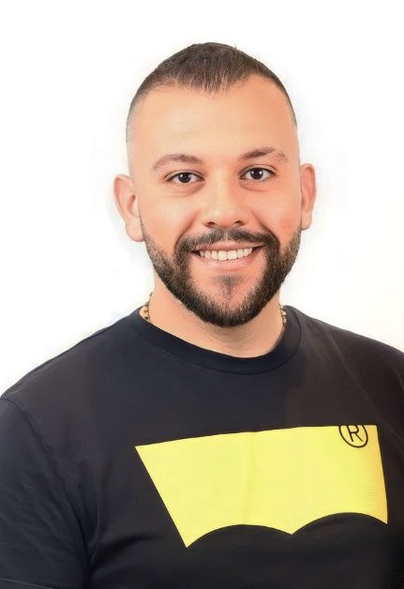  profile  A passionate individual dedicated to the field of marketing. I serve as marketing executive, immersing myself in the dynamic world of brand promotion with deep knowledge about market trends and consumer preferences.  Additionally, with an 8 years’ experience in the sales sector, I’ve gained invaluable experience across diverse array of industries…  And a freelance social media manager with more than 4 years of experience managing social media accounts from A to Z  Great communication skills and significant ability to work and perform well independently or in a team  Education  ▪ Antonine University - 2016-2020  Bachelor Degree in Business Marketing & Management  Skills  ▪ Sales target: reaching monthly sales target  ▪ Customer service skills: knowing customer needs and listening to their wants  ▪ Communication skills: ability to deliver a message in a clear and concise manner to suit the individuals and circumstance  ▪ Team work  ▪ Problem Solving  ▪ Social media planning  ▪ Content creation  ▪ Computer literacy:  - Competent in Microsoft suite:  (Excel- Word and Power Point)  - Adobe Photoshop  - Pics Art - Canva – Cap Cut  languages  ▪ Arabic: Native Language  ▪ English: Spoken and written fluently  ▪ French: Spoken and written fluently  internship  ▪ BBAC BANK – 2018  . Gained experience in customer service  . Achieved further knowledge in the design of debit and credit cards  . Worked closely and gained knowledge of every branch of the bank | experience  ▪ Marketing executive • garage souk lebanon • 2023-  - Presenting new ideas related to trolleys in Centro – City mall and City Center,  - Coordinating events and activities (Music festivals, Christmas Markets.)  - Conducting research and analyzing data  - Managing social media account  - Create and schedule content on all platform (Instagram, Tiktok, Facebook, X …)  ▪ TEAM LEADER • levis • 2022-2023  - Contact with customers to discuss needs  - Knowledgeable about the items  - Provide customer satisfaction  - Inside store Visual Merchandizer  ▪ inside sales representative • nike • 2022  - Sales and Helping customers with their needs  - Strong communication skills  - Good team work  - Cashier – POS system  ▪ Outreach worker • Common effort • 2022  - Develop and implement outreach plans  - Organizing media events  - Assisting individuals with social and psychological challenges by facilitating lifestyle programs and offering them the support they need  - Visiting schools, giving talks at assemblies, discussions with students, and participating in events  ▪ Team Leader • JENNY’s BY J.R • 2020-2021  - Gained experience in data entry  - Gained experience using POS System  - Creating new ideas and thinking outside the box  ▪ freelance social media manager • 2020-present  - @Otocar_rental, @garagesouklebanon, @Najwakaramcloset, @Phimolb, @Newbeaver, @Decobysandro  ▪ Inside sales representative • polaver • 2019-2020  - Providing advices and maintaining excellent relationship with clients  - Experience in data entry  - Managing social media accounts  - Presenting and displaying items at Biel exhibitions  training and courses  ▪ Conflict Transformation and Communication Skills - 2019  Organized by the Center for Career Development in Collaboration with the center of continuing education Lebanon  ▪ GBV & Child Protection Training with RDFL - 2022  ▪ Outreach Training in School  ▪ IT Beginner  ▪ Social Media  ▪ Communication Skills  ▪ Business Etiquette
  sandro elie msaeed
  BUSINESS marketing and management
  00961 03 733791 - Sandromsaed_1996@hotmail.com - beirut

