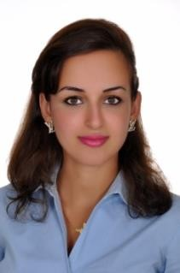
Mariam Wehbeh
Phone:71292970
Email:Mariamwehbeh@outlook.com

Education

- MBA from Modern University for Business and Science (MUBS), Beirut, Lebanon.2014
- Master in Economics (Preparatory courses) in Beirut Arab University (BAU), Beirut, and Lebanon.2013
- Bachelors in Economics (BA) from Beirut Arab University (BAU), Beirut, Lebanon.2010
- Lebanese Baccalaureate in Economics and Sociology from My New College School, Beirut, Lebanon.2006

Experience

Working as order management associate at ETHAN form Sep-23 Till Feb-24
- Managing all aspects of sales order including creation and submission of orders to suppliers.
- Owning and managing all backorders per the prescribed process within SLA.
- Managing all operational activities associated with a sale order which include stock allocation, eta management, products return, part number creation.
Teller in Bank of Beirut from 2013 Till 2023 providing the below tasks:
- Serves customer by completing account transaction.
- Provides account services to customer by receiving deposits and loan payments.
- Cashing checks.
- Issuing savings withdrawals.

Training

- English courses in British Council Beirut, near France Embassy, Lebanon Oct-Feb 2010.
- Bank of Beirut, Riad El Solh Branch, Beirut, Lebanon from July-August, 2007.

Certificates

• Lebanese Financial Regulation from École supérieure des affaires (ESA), Beirut, May 2018.

Skills

- Computer Skills, Advanced clerical knowledge, Strong account analysis skills, Rapid data entry skills, Consumer banking specialist, Accounting systems and software, Financial analysis, Positive, Self-sufficient, Excellent time management skills.

Language

- Fluent in English and Arabic (writing, reading, speaking).

Recommendation
Upon request

