MOHAMAD SHAHEEN 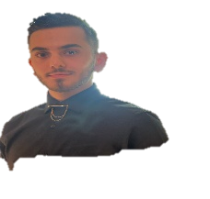
Web Developer
Address: Lebanon - Beirut
Email: mohamadshaheenceng@gmail.com
Mobile: +961 71113515

Career Objective:
Senior full stack developer, using latest technologies and frameworks to increase quality and productivity.

Skills:
Material design - bootstrap
Python
MySQL.
GIT-GitHub.
Expert in data base management system(SQL).

Education:
Oct 2021 - June 2024
Lebanese International University.
Computer & Communication Engineer
Acquired a large knowledge of the fundamentals of computer science/engineering.

Projects:

- PRIVATE DOCTOR CLINIC PROJECT.
- POLY-CLINIC SYSTEM PROJECT.
- RESTAURANT MENU.

Working Experience and achievements
- Online tutor for university students in programming languages for a two years.
- Online tutor for External programming boot camp courses for one year.

Language Skills:
- Arabic (native language): proficiently spoken, read, written and comprehended
- English: read, written and comprehended
- French: read, written and comprehended

Technical Skills:
- Computer skills (Microsoft Word, PowerPoint, normal typing).

