Mohammad Mohsen Ghoul
📧 Email: aalghool090@gmail.com
📞 Phone: +961 76 632 614
🔗 LinkedIn: mhmmad ghoul
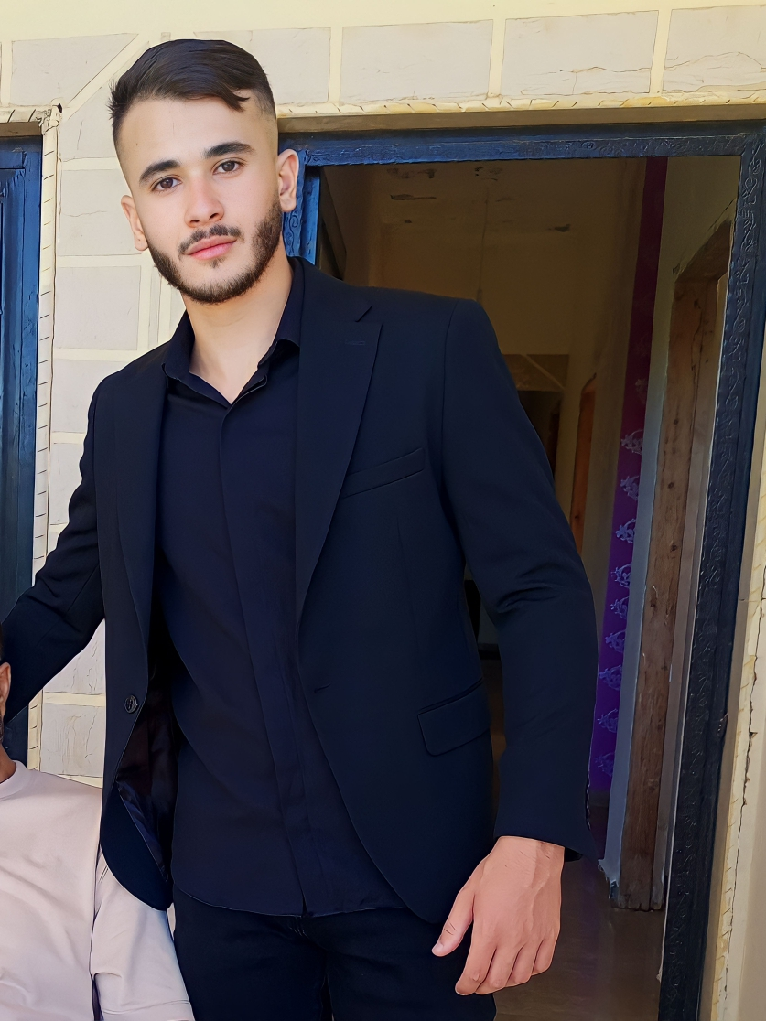
————————————————————————————————————————

Professional Summary
Passionate and dedicated Cybersecurity student with strong technical and analytical skills. Currently in my 3rd year at Usal University, Lebanon, I possess hands-on experience in programming, networking, ethical hacking, and full-stack development. I have worked on several academic and personal projects, applying Java, Python, C, Flask, Spring Boot, and React to solve real-world problems. Strong understanding of networking concepts through Cisco training, and practical experience working with Snort IDS for intrusion detection. I am eager to continuously develop my skills and contribute to innovative and secure technological solutions.

Education
Bachelor’s Degree in Cybersecurity
Usal University, Lebanon (Expected Graduation: 2025)
Relevant Courses: Cisco Networking 1, 2, 3, Object-Oriented Programming (OOP), Ethical Hacking and Penetration Testing, Software Engineering

Technical Skills
Programming Languages: Java, Python, C, JavaScript
Frameworks & Tools: Flask, Spring Boot, React
Networking: Cisco Networking (CCNA 1, 2, 3), Network Security, Snort IDS
Software Development: Full-Stack Development, GUI Design, API Integration
Algorithms & AI: K-Nearest Neighbors (KNN), Machine Learning Concepts

Certifications
🎓 Cisco Networking 1
🎓 Cisco Networking 2
🎓 Cisco Networking 3

Projects
💻 Budget Expense Tracker
Developed a web application using Flask for backend, with user authentication, expense management, and reporting features.
💻 Credit Card Fraud Detection System
Built a fraud detection system using KNN algorithm, analyzing transactional data to identify fraudulent activity. Focused on data preprocessing, model training, and evaluation.
💻 Patient Management System
Developed a desktop GUI application using Java (OOP) for patient data management and appointment scheduling. Applied software engineering principles for requirement gathering, design, and development.
💻 Face Recognition System
Implemented a face recognition system for authentication purposes, exploring computer vision techniques and Python libraries.
💻 Intrusion Detection System (IDS) with Snort
Configured and tested Snort IDS as part of an Ethical Hacking project, creating custom rules and analyzing traffic for suspicious activity.

Languages
🗣️ Arabic: Native
🗣️ English: Fluent

Hobbies & Interests
⚙️ Problem Solving & Algorithm Challenges
🏅 Sports & Fitness
💡 Exploring New Technologies in Cybersecurity and AI

