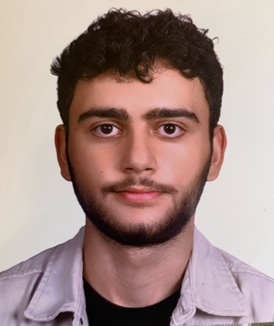

^{Name: Ali Sheikho}
^{Nationality: Lebanese}
^{Phone number: 81608613}
Email: alijrsheikho323@gmail.com
^{Birth date: 21/3/2005}
Graduated from: Adventist School (MASS)
University: Beirut Arab University (Bau) / American system freshman / Finance
Languages: English & Arabic

Experience:
Sales Associate (Retail)
Azadea Group – Pull & Bear, Beirut, Lebanon
July 2024
- Assisted customers with product selection and ensured a high standard of customer service.
- Maintained store presentation, restocked merchandise, and supported daily operations.
- Collaborated with team members to achieve sales targets and ensure smooth store performance.

