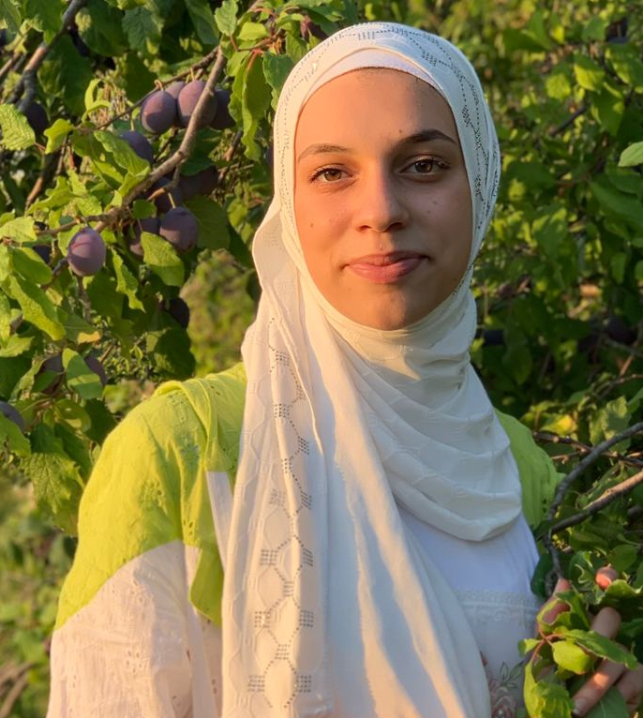 |  |  | Alaa Abdl rahman  Education  Fnaydek high school , fnaydek  - bachelor in life sciences 2020 – 2021 the total : 14.944/20  Certificate  Personal strategic planning Alemni Foundation  Time management Alemni Foundation  Basics in power point Alemni Foundation  Artificial intelligence DOT Lebanon  Digital media literacy DOT Lebanon  Robotics Alemni Foundation  Figma Alemni Foundation  skills  Micro soft office  teamwork  problem solving  communication  creativity  writing  illustration  languages  Arabic : reading , writing , dialogue - excellent  French : reading , writing , dialogue - excellent  English : reading , writing , dialogue – good  hobbies  graphic design , reading books , writing , drawing , fashion design , photography , video making , editing , sport .
 | LEBANON  AL KORNEH AKKAR
 | +9613297417
 | ab8939833@gmail.com
 | Date of birth : 14/3/2004

Objective
My name is Alaa Abdl Rahman , I am a girl , I was born on 14/3/2004 , I study IT management at the Lebanese university , faculty of business administration , I have experience in creating infographics , editing photos and videos , and making a logo , I am organized at work , and punctual , and I am able to take responsibility and organize my time under pressure .

