Nabil Alawar  Marketing Student | Digital Marketing | Brand Communication | Customer Experience  Phone: 71299172  Email: nabilalawar19@gmail.com  LinkedIn: https://www.linkedin.com/in/nabil-alawar 964971398?utm_source=share&utm_campaign=share_via&utm_content=profile&utm_medium=ios_ app  Qornayel, Mount Lebanon | 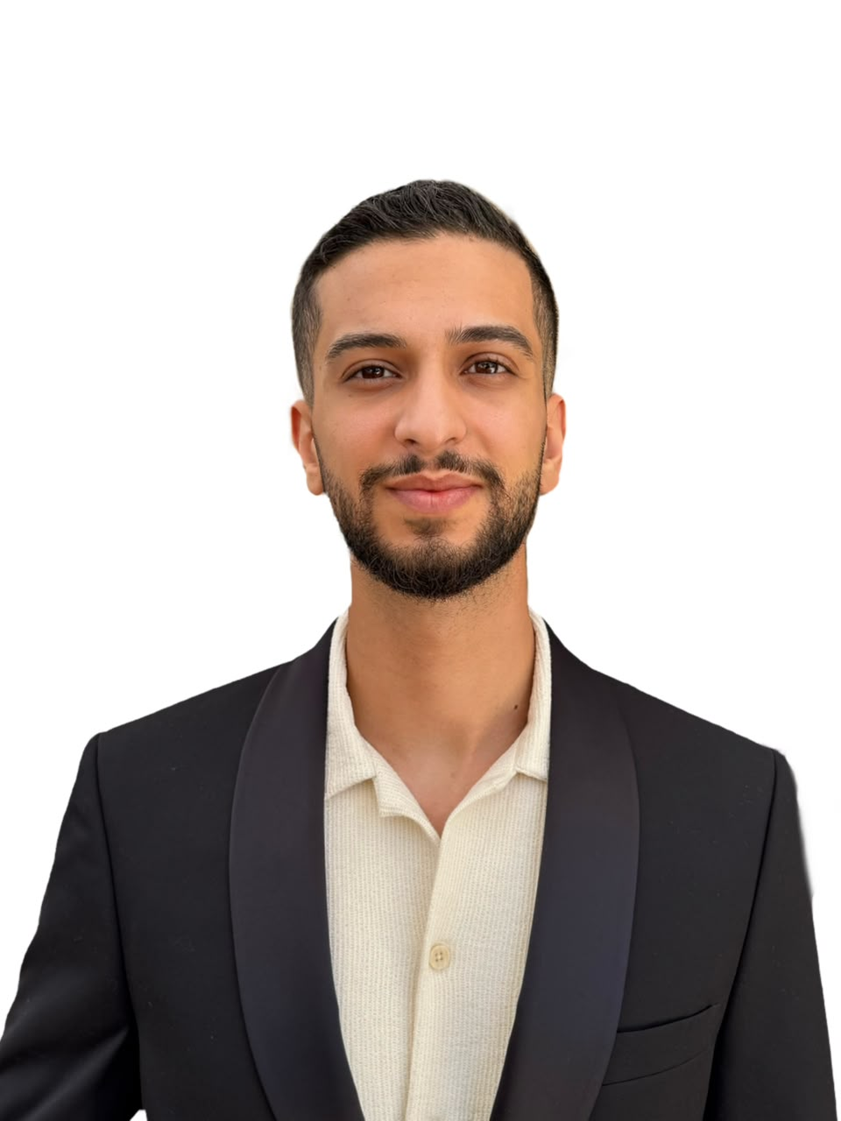

Profile
Motivated Marketing student at Modern University for Business and Science (MUBS) seeking a marketing internship opportunity to gain hands-on experience in digital marketing, branding, customer experience, and business development. Combines academic marketing knowledge with international exposure, customer-facing experience, and strong communication skills developed through professional work, Erasmus+ mobility, and international presentations. Passionate about learning, creativity, and contributing to impactful marketing projects.

Education
Modern University for Business and Science (MUBS)
bachelor's degree in marketing | 2023 – Present
Institut Libanel Technique (ILT)
Survey Engineering Diploma | 2020 – 2023

International Experience & Achievements
Erasmus+ Student Mobility Participant
Powislanska Academy of Applied Sciences, Poland | 2026
• Participated in an international academic exchange programme.
• Strengthened intercultural communication, teamwork, and adaptability skills.
• Experienced collaboration in a multicultural environment.
International Student Conference Speaker
Powislanska Academy of Applied Sciences | 2026
• Presented research on management and communication in Lebanese organizations.
• Developed professional presentation, research, and public speaking abilities.

Experience
Production Assistant | Carpentry Establishment
Qornayel, Mount Lebanon | 2020 – 2025
• Supported daily operations, workflow organization, and team coordination.
• Managed preparation activities while maintaining quality and efficiency.
• Developed problem-solving, responsibility, and operational skills.
Dispatch / Outgoing Goods Assistant | Soha Factory
Falougha-Khalouat | 2017 – 2019
• Verified outgoing products and maintained accurate records.
• Coordinated with teams to ensure smooth delivery processes.
Customer Service Staff | Horse Ride & Natural Land Activities
Mount Lebanon | 2014 – 2017
• Delivered customer service and managed customer requests professionally.
• Developed communication and relationship-building skills.

Marketing Skills
• Digital Marketing Fundamentals
• Social Media Marketing
• Market Research & Consumer Understanding
• Marketing Strategy Fundamentals

Skills
• Communication
• Public Speaking
• Teamwork
• Problem Solving
• Time Management
• Adaptability
• Organization

Technical Skills
Microsoft Word | Microsoft Excel | Microsoft PowerPoint

Volunteer Experience
• Caritas Archdiocese of Gdańsk – Youth House Meeting Initiative Volunteer | 2026
• Participated in youth activities and intercultural community initiatives.
AFDC Volunteer | Qornayel, Mount Lebanon | 2019 – 2020
• Supported environmental and community projects.

Languages
Arabic — Native
English — Very Good

Interests
Digital Marketing | Branding | Business Development | Public Speaking | Continuous Learning

