Marie-Claire Kordahy

Achrafieh, Beirut
Phone: 76-659733
E-mail: mckordahy71@gmail.com

Summary Business Management student, with the ability to learn and develop new skills quickly and efficiently, that have made it possible for me to work well on assigned tasks both alone and within a team. I was exposed to marketing campaigns and events as ABC customer service representative and sales promoter at Fawaz Holding; which sparked my interest and curiosity leading up to electing what I would like to do in the future. Energetic and driven, I worked further filling small roles in event planning and it enforced my conviction that I would like to study Marketing and Event Management later on.

Education Inspire Fitness Academy July 2018 – November 2018

Fitness Instructor Course, American Council on Exercise Educational Partner, Licensed by the Ministry of Education, Accredited by Europe Active, Active IQ Approved Center

Sagesse University Fall 2010-Present

Bachelor of Science in Business Administration and Finance; minored in Marketing.

Immaculet Conception 2007-2010

Technical Baccalaureate in Accounting. (BT)

Skills Computer Skills: - MS Office: Word – Excel - Outlook - PowerPoint - Publisher - Internet research - CRM Software – TalkWalker - Capital

- Adobe : Photoshop - Illustrator

Languages English – French – Arabic: Full proficiency

Other Skills Accounting - Online Marketing: SEO/ SEM Marketing, Analytics& Tracking - Social Media Marketing – Customer Service – Sales - Bartending - Event Planning – Body Building – Circuit Training.

Experience

Freelance Content/Social Media Manager June 2017 – Present (2years)

Achievement: Increased Instagram, Twitter, Blog and Facebook engagement and client activity by 75% within the first 60 days of employment.

Launched and grew four social media communities.

Employed social media strategies to promote brands' products and services.

Conceptualized, imitated and implemented companies' social media strategy.

Developed brand awareness and composed online content.

Managed Facebook, Twitter, Instagram and blog accounts.

Designed, created and managed web based ad campaigns.

Analyzed reviewed and reported on promotional campaign effectiveness to maximize results.

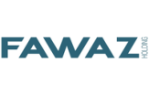 Sales Promoter November 2017 – July 2018 (9months)

(Moulinex, Krups, Rowenta, De’Longhi)

Achievemet: 1-Increased Sales of the brands in relation to competitor brands.

2- Increase customer loyalty to the brand

Demonstrate product to customers, at a store, during an event, or another venue

Show/explain how product is best-used and properly stored.

Answer any inquiry related to product.

Highlight the USPs of our product.

Take orders from companies for products and keep records on Excel.

Set up and arrange displays and demonstration areas to attract the attention of prospective customers.

Gather data and implement them on Excel for Benchmarks and Client database.

Participate actively in market research, benchmarking and other activities to improve our brand.

Deliver promotional and marketing plans in-store as briefed.

Monitor and manage the availability and stock level in the stores along with commercial teams.

 Sales Representative May 2017 – July 2017 (3Months)

Impose excellent customer service skills that comfort every walk in customers in order to achieve monthly sales target and other retail store obligations on a daily basis.

Being responsible for driving sales and achieving sales goals for the team.

On a daily basis, Contributing to every aspect of the business: running the store, maintaining top merchandising display based on brand guidelines and making sure that every person in the store feels welcomed.

Great and connect with the customers in a friendly and helpful manner.

Convert casual browsers into customers through enthusiasm and sincerity.

Provide excellent customer service skills to create best in class shopping experience and sales growth.

Be a brand ambassador at all times by understanding the brand’s core values with strong ownership and passion to succeed in this job.

Focus on the brand story and its authenticity, using it as a sales tool.

Best in class store and product management in terms of safety compliance, product quality and visual merchandising.

Be a reliable team member to work with especially under fast paced work environment.

Kept storerooms clean, tidy, organized and optimized.

Range of services is explained in detail, in order to win customer loyalty and encourage return visits: Alterations, Reservation, Exchange, credit note and gift vouchers.

 Head Waitress February 2016- February 2017

Achievement: 1- Solved operational issues in the pre-opening of the restaurant.

2- Trained the team for the best customer service and communication.

Greet and seat customers.

Give customers a tour around the shop explaining the concept.

Providing great customer experience through the best service and food presentation.

Monitoring staff schedules and smooth running of daily operations.

Providing daily and monthly reports, and assisting in cost control management.

Opening and closing of the shop.

 Freelance Fitness Instructor August 2016 - Present

(Fitness Zone, A Team, Phocus Gym, FR Gym,

Beirut Sports Academy)

Achievement: Increase sales on Personal Training packages.

Demonstrate how to carry out various exercises and routines.

Watch clients perform the exercises and show or tell them correct techniques to minimize injury and improve fitness.

Give alternative exercises during workouts or classes for different levels of fitness and skill.

Monitor clients’ progress and adapt programs as needed.

Explain and enforce safety rules and regulations on sports, recreational activities, and the use of exercise equipment.

Give clients information or resources about nutrition, weight control, and lifestyle issues.

Give emergency first aid if needed.

 Wedding and events Hostess September 2015 – August 2017 (2years)

Greet and direct guests upon arrival, providing them with information they need and answer other questions.

Coordinate with organizers, Featured guests, and other staff members such as caterers, artists and managers to ensure the event is on track and guests are enjoying themselves.

Maintain effective working relationships with other event workers, organizers and other involved parties.



Sales Promoter / Hostess March 2016 – Present (2 years)

Presented information to consumers with an already designated marketing strategic plan.

Having the product knowledge to give the right information to client.

Announce item on the agenda and recognize sponsors.

Filled out sales report and e-mail it to marketing assistant

Created an atmosphere of interest and expectation.

Meet with the organizer to learn about the overall event, the presenter and any special guest.

Recorded people's reaction towards product

Sales Manager October 2015 – February 2016

Achievement: Profitable launching of the newly opened stand in ABC Achrafieh.

Make a daily display of the Jewelry collections.

Keep track of daily sales and sales reports.

Present weekly and monthly sales reports.

Deal with contractors for any issues regarding the shop.

Supervise 2 Sales representatives.

Coordinate employees shift schedule.

Manage complaints and customer feedback.

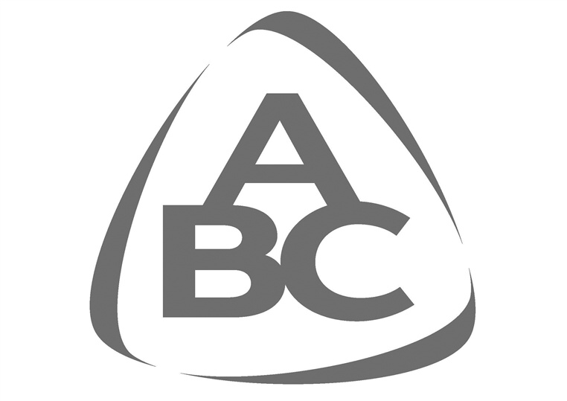

Customer Service Hostess September, 2013 –September, 2015 (2Years and 1 month)

Achievements: 1- Increase sales of the ABC credit card.

2- Ensure high quality customer service.

Learn required information on specific products and services.

Interacted with customers, applying required marketing procedures.

Actively engaged in customer issues follow up and solving them promptly.

Conducted surveys and gave accurate consumer feedback on new products/services, promotions and events.

Handled the Tax Free Forms issuing and Tax Free daily and monthly reports and implement them on Excel sheets

Handled Wedding list and Birth list accounts and Wedding list/Birth list monthly reports using Excel sheets.

Assisted actively in on ground monitoring, production, and execution of events.

Coordinated with on-premise marketing team.

Created and managed files containing critical required information of all customers’ data both on CRM and Excel.

 Cashier/Customer Service

Training Supervisor June 2010 – January 2012 (1year, 7 Months)

Achievement: Trained 43 cashiers to handle their responsibilities for both Achrafieh and Hazmieh branch opening.

Offer exceptional customer service by exceeding the customers’ expectations, through a friendly, positive and pleasant interactive approach and ensures all items are scanned and paid for.

Performing cashier spot checks to ensure well running of cash operations.

Performing opening and closing tasks ensuring all checklist tasks are done.

Handling cash floats and safe operations.

Assisting customers in the loyalty program and all related inquiries: Redemptions, Card Creation and collection.

Promoting the Spinney’s Gift Card.

Handling all customer complaints and comments effectively and efficiently to ensure the best customer experience.

Certifications and Awards

Customer Satisfaction – ABC sal training department -2014

Effective Communication – ABC sal training department - 2015

Comprehensive Online Marketing Certificate – Astrolabs Dubai & Beirut Digital District – May 2018

Fitness Instructor – Inspire Fitness Academy and EREPS – March 2019

Training

In Collaboration with

Comprehensive Online Marketing Workshop May 17 & 18, 2018

- Overview Digital Marketing Strategy: Understanding all Digital Channels and How To Develop A Strategy For Any Business.
- Push Marketing: Display Ads- GDN (Google Display Network), Programmatic Ads, Facebook, Instagram, Snapchat, Twitter & LinkedIn Ads. Practical Session: Creating Display Ads across multiple platforms.
- Optimizing the funnel: Making smart changes to your site for Conversion Rate Optimization, How to setup Retargeting (Facebook, Google and 3rd Party).
- Pull Marketing: SEM (Search Engine Marketing)- Adwords, setting up your first campaign, Ad groups, Keywords and Google Shopping Ads. Practical Session: Keyword Research, and creating Google Search Campaigns.
- Long term marketing: SEO (Search Engine Optimization)- Getting your site to rank high on Google organically, Organic Social Media (Automation, Growth Hacking & Content) and Influencer Marketing.
- Customer Retention: Digital CRM (Customer Relationship Management), Newsletter, Segmentation, Automation and Drip Campaigns.
- Analytics & Tracking: Defining Inbound Traffic, Goals, Events, Creating Reports and Dashboards.
- Advanced Digital Marketing Strategy: Defining key metrics and Optimizing budgets

Volunteer Experience

Les Jeunes de Caritas-Rmeil February 2010 - 2013

Conducting fundraiser campaigns and Assisted in monitoring, producing and executing kids summer camps.

Participated actively in youth training seminars.

Interests

I have interest in trying new things, taking part in exciting activities constantly pushing me outside of my comfort zone. I like to stay up to date with the music industry and clubbing, as well as with international business magazines. I enjoy sports (Body Building, Cross fit, Outdoor sports) , music, and sociology, watching movies/series and reading books.

