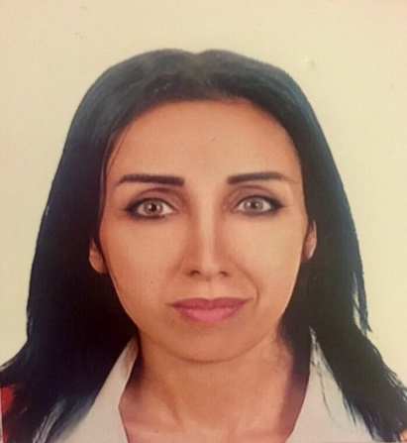

Zeinab Abdul Sater
Date of birth: 11th of May 1988
Nationality: Lebanese
Place of residence: Beirut-Lebanon
Gender: Female
Marital Status: Single
Mobile Number: +9613534756
Email: zaspress@gmail.com

Objective
I aim to gain as much experience as I can get, in a way that can help me bring success to the organization in which I work for, by being an outstanding staff member.

Education
- July-2009 BA in Mass communication and Journalism-Broadcast Journalism (Faculty of Information and Documentation- Lebanese University, Beirut-Lebanon)
- July-2006 high school degree in socio-economics

Experience
- October 2017 – Present
CARMA International – Beirut, Lebanon
Senior Creative Copywriter – Content creation department

- March 2013 – Present

Al Jadeed TV – Beirut, Lebanon

News Operator – News Reporter/Lel Nasher program

- January 2015 – October 2017
Super1Mag Football magazine – Beirut, Lebanon
Chief Editor – La Liga (Spanish league) Section

- September 2012 – February 2013
Al Diyar News Paper – Beirut, Lebanon

News Editor

- January 2011 – April 2011
Institute for War and Peace reporting (IWPR - NGO) – Beirut, Lebanon

Program Assistant

- June 2010 – September 2010
United Nations Youth Association (UNYA) - Beirut, Lebanon

PA president & Media Coordinator

- January 2010 – June 2010
Media Link International - Beirut, Lebanon

Project Manager

- January 2009 – April 2009
The Top Talent - Beirut, Lebanon
Data entry free lancer

- January 2007 – Jan 2009
Al Akhbar newspaper – Beirut, Lebanon
Free Lancer Journalist

Languages

Arabic – native: read, write & speak

English-fluent: read, write & speak

French-Fair: read, write & speak

Computer skills
- Knowledge of Ms Office (word, excel, power point, etc)
- Data entry
- I News (Access, Assist, Capture)
- Internet Browsing
- Researcher
- SEO and SEM

Specialties
Video editing and montage (good in using Adobe premiere and similar programs). Writing and editing (in Arabic and English mainly). Photography (know how to work using Adobe Photoshop). Excellent communications skills.
Skills
▪ Great deal of common sense and logic.
▪ Diplomacy and excellent negotiation skills.
▪ Continuous Learner staying abreast of all Media, journalism and social Media trends.
▪ Excellent typing skills.
▪ Advanced research capabilities.
▪ Presentable with an outgoing personality.
▪ Team work spirit as well as individually.
▪ Able to work under pressure and meet deadlines.
▪ Willing to travel.

Interests

- Sports,
- Social Media,
- World Politics
- Social activities,
- Management Training,
- Music,
- cooking
- Camping,
- Traveling,
- Reading,
- Writing poetry,
- Swimming,
- Photography

Qualifications

- Work shop with Freiderch Ebert NGO / The role of journalist during civil war.
- Work shop with Freiderch Ebert NGO / The role of journalist in increasing citizenship.
- Work shop with Maharat NGO / Investigating journalism.
- Workshop with United Nations Youth Association / Documentary making.
- Training courses in journalistic and communication skills.
- Volunteer in the INTERNATIONAL JOURNALISM FESTIVAL2010/Perugia-Italy
- Training courses in film directing.
- Voice Over Courses at Sawt Al Shaab Radio Station.

Awards, Fellowships, Grants

Journalists without Bounds
Member-2008 / present

Annahar Newspaper - Nahar AL Shabab
Member-2007 / present

United Nations Youth Association
Board Member-2009 / present

Lebanese University - Faculty of information and documentation
Member of student council-2007-2008-2009

Publications
- Articles-Al-Akhbar news paper-2007-2008 (http://www.al-akhbar.com/node/128428 )
- No2at 3al 7ourouf magazine ( http://no2at3al7ourouf.com/suburbs/?p=₁₈ )
- News Reports (www.aljadeed.tv )
- http://www.aljadeed.tv/arabic/news/news-reports/20082016
- http://www.aljadeed.tv/arabic/news/news-reports/0810201610
- https://www.youtube.com/watch?v=8NfuRfpvOYk
- http://www.aljadeed.tv/arabic/news/news-reports/020620164

- Sports Articles ( www.super1mag.com )

References

1- Name: Bissane Tay

Former position: Head of investigations’ department at Al-Akhbar news paper

Current position: Researcher and Assistant director for documentaries at Al-Jazeera

E-mail: bissantay@gmail.com

Phone number: 00961 3 268357

2-Name: Farah Abdul Sater

Former position: Director of programs at UNYA-Lebanon

Current position: Communication Consultant for the MENA region – World Bank – Marseille, France

E-mail: farahabdulsater@gmail.com

Phone number: 0033661932375

3-Name: Dora Shams Al Ghazal

Current position: Senior HR Officer at Al-Jadeed TV

E-mail: dora@aljadeed.tv

Phone number: 00961 1 303300 (ext. 182)
Mobile number: 0961 3 419631

4- Name: Susanne Fischer

Current position: Middle East Program Manager at IWPR

E-mail: susannef@iwpr.net

