CURRICULUM VITAE 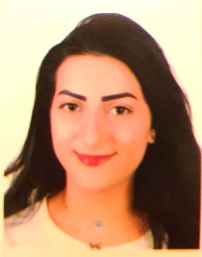

CORE INFORMATION

PERSONAL DATA :
Name : Dana Beydoun
Address : Beirut – Lebanon
Mobile : +961 71316128
Email : dana_beydoun@live.com
Date of Birth : August 24th 1993
Nationality : Lebanese
Marital Status : Single

EDUCATIONAL QUALIFICATIONS

EDUCATIONAL BACKGROUD :
- Studied hotel management at Lebanese University Faculty of Tourism and Hospitality Management.
- Baccalaureate secondary (Economics and Sociology) in Beirut in September 2013.

WORK EXPERIENCE

-At Intercontinental Phoenicia Hotel:
From May 23rd 2018 till August 31st 2018
- Cluster Reservation Officer (Phoenicia & Le Vendôme Hotels)(Sister Hotels)

-At Le Commodore Hotel Hamra:
From April till May 2018
- Reservations Agent

From October till March 2018
- Receptionist

-At Golden Tulip Serenada Hotel Hamra:
From June till August 2016:
- FO training “Reservation” (Covered two and a half months, with total of 310 hours) (PMS System)
- Housekeeping training (1 week)

-At Ramada Beirut Downtown Hotel:
From June till September 2015:
- Hostess & waitress at Scarlet Lounge
- FO training (Covered 29 days of training, with a total of 181 hours)(Opera System)
- Housekeeping training (2 weeks)

-At Movenpick Hotel :
From May till August 2014:
- Bartender at Hurricane Pool Bar
- Hostess & waitress at Mediteranne Restaurant

COMPUTER LITERACY

Microsoft Word, Excel, Power Point, Adobe Photoshop, and Internet Resources.

LANGUAGES

English : Good
Arabic : Mother Tongue
French : Average

PROFILE

PERSONAL INFORMATION:
- Outgoing person who enjoys socializing
- I love to travel
- I am dynamic person with high standard of honesty
- Self confidence
- Like to work among a team

REFERENCES

Mr. Ahmad Siblani- Supervisor at Movenpick Hotel 03-945033
Mr. Joe Bou Khalil-FO Manager at Ramada Hotel 03-276631
Mr. Mustafa Kawtharani-FO Manager at Golden Tulip Hamra Hotel 03-786193
Mr. Elie Khairallah-FO Manager at Le Commodore Hotel 03-312747
Ms. Sara Awada-Reservations Manager at Le Commodore Hotel 76-977116
Mrs. Sandra Khalil-Revenue Manager at Intercontinental Phoenicia Hotel 70-314433
Mr. Paul Hajj-Reservations Manager at Intercontinental Phoenicia Hotel 03/374734

