Omar W. Oseili
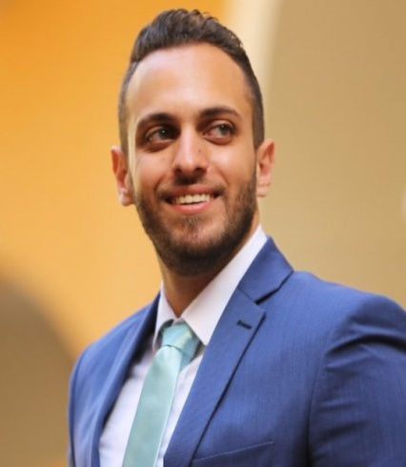Personal information

Social Status: Single
Nationality: Lebanese
DOB: March 5th, 1993
Permanent address: Beirut, Tarik El Jdideh, Abou Sahel St.
Contact information: omar.oseili@outlook.com| +96171477616

Objective
- Seeking a challenging position in a company that will fully utilize my skills and experience and further enhance my abilities& knowledge, and to obtain a position that will enable me to use my strong organizational skills, award-winning educational background, and ability to work well with people.

Professional Experience
- July 2017 – Present Makhzoumi Foundation – Beirut – Lebanon
Field Service Coordinator

- Coordinates monitors and improves field’s service activities for an organization.
- Provides supports and guidance to service personnel who perform on-site routine services including installation, maintenance, and repair.
- Ensures fields services are effective and customers’ requirements are met.

- November 2014 – July 2017 RGH Holdings – Inkript Beirut, Lebanon
Sales Assistant Manager
- Responsible for the contact between the salesmen and the Production ,Planning, Accounting ,Messengers, Warehouse and Designers ,
- Data Entry for the sales orders (Quantity,Price,Date, etc…) on the internal software (Noria).
Key areas of responsibility:
- Production orders that are sent to planning.
- Follow up with the accounting for all the Debits and Credits related to the Company
- Follow Up with the Warehouse to get the Delivery Schedule.
- Track the progress of weekly, monthly, quarterly and annual objectives.
- Communicate with clients and evaluate their needs
- Assist the Manager in planning and implementing strategies to attract customers.

Education
Nov. 2017 – Present Cyprus International University Lefkosa, Cyprus Doctorate in Business Administration – D.B.A

Feb. 2015 – May.2017 Arts, Science & Technology University of Lebanon Beirut, Lebanon
Master’s in Business Administration.

Sept. 2011 – Sept. 2014 Arts, Science & Technology University of Lebanon Beirut, Lebanon
Bachelor of Science in Business Administration
Dual Concentration: Management
Graduated in Summer 2014.

Skills and qualifications
- Computer skills: MS Excel, Word, PowerPoint, Outlook, Omega, Noria.
- Languages: Fluent in English and Arabic, written and spoken, Fair in French
- Acquired skills:
- Energetic
- Self Motivated
- Meticulous
- Team player
- Systematic, organized and punctual
- Cope easily
- Eager to learn
- Work well under pressure
- Good time management skills
- ILETS Certificate.
- WES (World Education Services) Certificate.
References: Dr. Daher el Aily (76/411 151)
Dr. Mohamad Kaddouha (03/504 246)
Dr. HoussamRjoub (+90 542 878 21 28)
Mr. Nabil Naamani (03/081 871) < Makzoumi Foundation>

