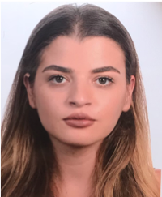 |  | Leyla  Salam  Law Student
Profile  An ambitious, focused and committed law student. As a law student, I am capable of working in fast-paced environment and of meeting strict deadlines, completing casework in a highly efficient manner. Able to work independently and as part of a team and can make valuable contributions to any legal team, thanks to my strong research, communication and client-care skills.  Currently seeking an internship or part-time or full-time position in a challenging and stimulating environment that allows me to proove myself and improve my skills.  CONTACT  PHONE:  76030500  LinkedIn:  http://linkedin.com/in/leyla-salam-  9233a688  EMAIL:  leyla_salam@hotmail.com  ADDRESS:  Beirut-Mazraa- Salam bldg-1st floor  DATE OF BIRTH:  29-10-1997 |  | EDUCATION  Filiere Francophone de droit-Lebanese University  2015 - 2019  One of the top Law schools in Lebanon, affliated with top French Universities.  Studying the Lebanese laws in comparison with the French laws  Lycee franco-libanais Verdun  2000 – 2015  French baccalaureate and it’s equivalence to the lebanese one  SKILLS  Communication  Research  Time Management  Persuasion  Public speaking  Languages  English, French, Arabic  Fluent in all them (writing, speaking, reading)  Conferences  2017-10 Refugees: political questions and legal approach- USJ  2017-05 The pros and cons of a career in international law - FFD  2018-02 The right to privacy and the protection of personal data- FFD  2018-03 Reform of the french civil code-FFD  2018-04 Realism in law  2018-04 Protection of human rights- USJ  Software  MS Excel, Powerpoint,Word  Email, Web and Social Skills

