SAEED salam
Date of birth: 26-07-1996| Nationality: Lebanese
Address: Mazraa- Mohammad Al Dana Street - Salam Building - 1st floor
Tel: 00961-70763741| E-mail: mett_1019@hotmail.com

 |  |  |  | 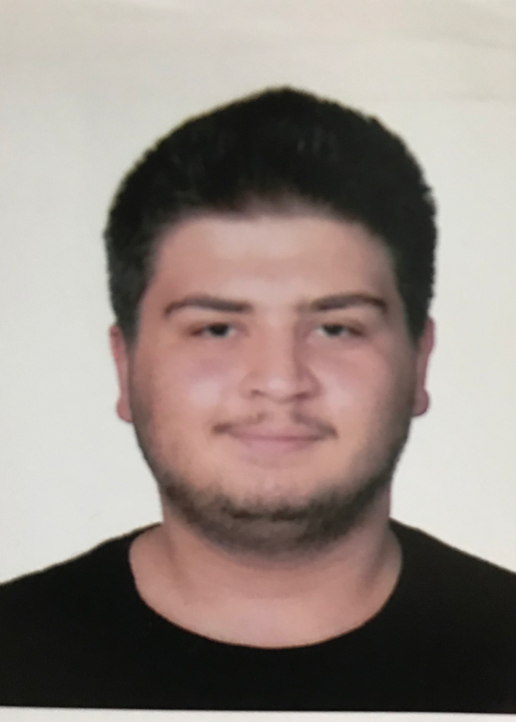
EDUCATION
Modern University of Business and Science  - BS Degree in Business Management double degree from MUBS and Cardiff Metropolitan University(UK)  - Program taught in English all in association with Cardiff Metropolitan University and BAL(British academy in Lebanon)  Universite saint Joseph 2015-2016, Beirut - Lebanon |  |  | September 2016-present  June 2016
- BS. Degree in Business in french
- Completed first year
Ecole Notre Dame 2012-2015, Beirut – Lebanon |  |  | June 2015
- Lebanese Baccalaureate in Economics and Social Sciences
Lycee Verdun from 1999-2012, Beirut – Lebanon |  |  | May 2012
- Lebanese Brevet Degree
WORK EXPERIENCE
 |  |  | February 2017-July2017
COOP- Cashier, Bourj Abi Haidar
- Although the majority of my time was spent as cashier, my work at coop was not only limited to cashier. In fact, I worked with stock keepers and suppliers as well. Furthermore, I learned how to deal with stocks and fill the stands with goods in regards of stocks, and for suppliers, I have not only learned how to pick up goods from the suppliers, but also the complete process of ordering materials (which starts with checking the present stocks and ends with ordering stocks and receiving them).

- During my work at Coop I have always satisfied my customers. In fact, I was very friendly with the customers that came to me and therefore attracted new customers who only wanted to be served by me because of my ability to serve them quickly and effectively.
SKILLS
English:  Arabic: | Speaking, Reading, Writing  Speaking, Reading, Writing
French: | Speaking, Reading, Writing
Computer: | Strong skills in Microsoft excel, word, power point, and in P.O.S (cashier system)
ACTIVITIES AND INTERESTS
- Personal traits: punctual - dedicated and committed to work- good in hard situations – friendly and like to help
- Sports: Played Football for 5 years & Basketball and badminton were my favorite hobbies when I was younger
- Camping- reading-movies -video games - going out with friends

