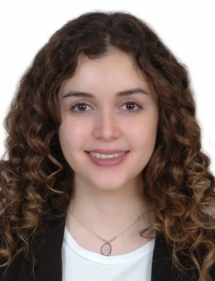
Lama Hatoum
Beirut,Lebanon
00961-71432688
Email: Lama.hatoum29@gmail.com – Lebanese/Canadian

OBJECTIVE
- My goal and aspiration is to secure a career opportunity in which I can fully utilize my skills in: the production department of a TV show or film/series set. In addition, I aim to also use my creative, organization and communication skills to achieve a job in the advertising and public relations department since any television show, series or film needs to get out to the public, I find that these two domains complete each other.
EDUCATION
`
Lebanese American University (LAU),Beirut,Lebanon June, 2018
- Bachelor of Arts in Television and Film with a minor in Advertising and Public Relations (Honors)
College Elysee, Beirut, Lebanon 2009-2015
- French Baccalaureate Diploma
EcoleJeaunne-Lajoie, Toronto, Canada 2000-2009

EXPERIENCE
- Acting Workshop – Lebanese Film Academy with Professor Takla Chamoun July 2018
- As Capstone Project: Produced two senior short films February- April 2018
- Anagnorsis: A Moment of Recognition
- Honorable mention: Best student film at Los Angeles Film Festival, New York Film Festival, and European Cinematography Awards.
- War2a w 7elem
- My job required many responsibilities such as:
- Coordinating with both directors’ on the locations needed for the film, casting sheets, call sheets finding sponsors, getting props and costumes ready for the shoot, creating the budget list of both films, managing time of each shot and following up with all cast and crew to make sure filming is completed on due date.
- Attended Salzburg Global Seminar- Salzburg Academy on Media and Global Change July-August 2017
- Internship at NBN in the TV Production Department June 2017
- Internship at MTV in the TV Production Department May 2017
- Improvisation Workshop- Lucien Bourjeily June 2016
- Bright I Workshop- TV Presenting March- May 2016
- Acting Workshop- Sevan Bakir March-April 2016
- Student Production : Doll Cargo October- November 2015
- Position Held: Actor main role

SKILL SUMMARY

- Computer: Microsoft Office (Word, PowerPoint, Excel), Outlook.
- Editing skills: Video editing (AVID), podcasting, picture editing, and blogging.
- Language: Arabic (Native) - English (Fluent) - French (Fluent).
- Soft skills: Strong leadership, excellent communication, and good team and time management

INTERESTS AND HOBBIES
`
- Sports: Tennis, dancing, hiking, and swimming.
- Others: Acting, voluntary work, traveling, and social networking.

REFERENCES

- References and copies of degrees will be available upon request.

