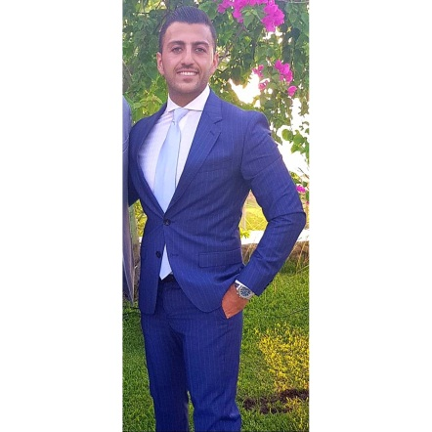
Saad Oueini

Address: Lebanon, Beirut
Phone Number: 00 961 3 644034
Email Address: saadoueini@outlook.com

Personal profile:
Enthusiastic, reliable and friendly individual who works hard to achieve his potentials. Adaptable, committed, well organized with good time management, communication skills and ability to speak other languages. A quick learner who is always seeking learning opportunities. Work well in teams as well as individually.

Personal Information:

Nationality: Lebanese
Date Of Birth: 5/3/1991
Gender: male
Marital Status: Single

Education:

Postgraduate Diploma in Marketing Management
American University of Beirut (AUB)
Lebanon, Beirut
Starting date: February 2015 to September 2016

Bachelor Degree in Business administration
American University of Science and Technology (AUST)
Lebanon, Beirut
Graduation date: September 2013

Work Experience:

- U-Food

Junior Brand Manager (from 5/2017 to 6/2018)
I was handling several brands in the continental cheese category such Boursin, Rians, Granarolo…
- Managed the assigned brands by preparing the commercial, analytical and marketing activities studies and reports.
- Assisted the Marketing and Sales managers in concerned meetings of related brands/categories.
- Built in collaboration with Marketing and Sales managers the yearly sales target per brand per SKU per channel per client.
- Tracked the Brands performance through sales and marketing reports by channel, by region, by supervisor by salesman by SKU.
- Built a yearly Marketing plan and activity calendar showing by month, by brands, by channel, by categories: major trade offers, major consumer promo offers, ATL and BTL Marketing activities, Tactical activities and promotional events.
- Planned and justified exhibitions and events.
- Suggested and tracked Marketing campaigns then prepared performance analysis reports of “pre” and “post” campaigns, analyzed and make recommendations to concurrent programs for corrective modifications.
- Calculated all estimated Marketing costs and follow up closely through the year.
- Reported to the Marketing manager by presenting my monthly activities and their analysis and recommend future action plan if necessary.
- Planed, prepared and coordinated in time all needed POSM: packing, stickers, barcode, off shelf rental in coordination sales department and merchandising unit.
- Performed continuous competition benchmarking and suggest price positioning when necessary.
- Monitored and archived competitors marketing activities calendar by collecting retail outlets flyers.
- Coordinated orders placing with the purchasing department
- Monitored and coordinated closely with the merchandising unit to secure planograms, POSM and off shelves are in place.
- Trained merchandisers on regular basis.

- Hikma pharmaceuticals

Consumer healthcare department (Vitabiotics)
Trade Marketing specialist (Beirut to North) from 10/2016 to 4/2017

- Leaded trade marketing initiatives to ensure proper strategy is in place to meet both brand and customer expectations
- Identified and developed necessary Point of Sales tools to increase brand presence, market share and improve customer satisfaction
- Created and maintained trade calendar of activities working with both the Retail & Marketing team
- Monitored and evaluate activities to measure effectiveness and recommendation of improvements as needed
- Implemented and tracked Trade Marketing programs for retailers with commercial and 6marketing teams designed to increase sales and brand/category presence.
- Carried out specific Trade Marketing programs, respecting company commercial policies, company strategy with the retailers and brand equity
- Worked in collaboration with the sales team in order to achieve the trade as well as activities target
- Reported sales needs and field intelligence to commercial / marketing teams
- Analyzed brand sell through results by channel and make recommendations to increase results
- Managed budget and ROI for Trade Marketing activities

- Nestle
Lebanon sales office (food products)
Modern trade sales department, Sales and Marketing Executive
From 5/2014 to 10/2016

- I was Accountable for the achievement of the set territory sales volumes
- Achieve the set coverage, core distribution and visibility targets in the assigned
area
- Ensured listing of new SKU's and the achievement of the POP objectives
- Promptly communicated trade and competitors information to management
- Ensured that the promotional program is implemented effectively and efficiently
in stores
- Competitive and trade Information (Market intelligence)
- Updated Planograms by Category / Brand
- Ensured collection is made in line with Nestle set payment terms
- Developed proper relations and rapport with customers and account personnel
- Ensured shelf and warehouse stocks are correctly audited, rotated (FIFO), and
the short term expiry issues.
- Ensured full implementation of the shelving, space, visibility and display as
agreed between Nestle and customers
- Submitted and maintained proper customer records, sales activities and other
required reports and forms claims
- Worked in accordance with the predetermined call plan
- Participated in different Marketing project such (Scan project, consumer behavior
Consumer insights projects, CATMAN)

- Azadea group
( Zara and Gap)
Sales coordinator
From 9/2012 to 9/2013

- Dunkin’ Donuts
Shift supervisor
From 3/2010 to 2/2012

Awards & Achievements:
- Negotiation skills (certified training : smart man)
- Sales techniques (certified training : smart man)
- Merchandising skills ( Nestle )
- Certificate of attendance in English for business writing ( British Council )

Skills:
- Languages: Arabic: mother language
French: intermediate level
English: upper intermediate level
- Computer: Microsoft Office Applications and Internet research, excel pivot
- Persuasion
- Communication skills
- Team work
- Initiative
- Flexibility
- Proactivity
- Problem solving
- Time management
- Creative

