Mohammed Oussaily
Tarek Al Jadida, Beirut, Lebanon | 71-112047 | mhmd.os@live.com
February, 10th, 1995 – Beirut, Lebanon

Education

CIVIL AND ENVIRONMENTAL ENGINEERING | 2013-2018 | Beirut Arab University
- Academic Projects
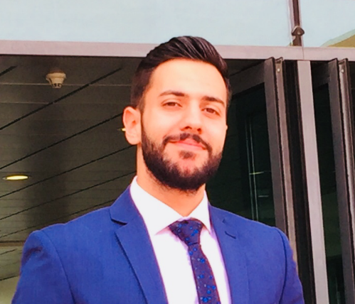
Steel Design II: Steel Frame Warehouse

Reinforced Concrete II: Design of Solid and Ribbed Slabs using ADAPT

Reinforced Concrete Design I: Design of Walls and Core Walls for a 10 Story building

Geology And Photogrammetry: Finding the exact dimensions of a specified land using data provided by aircraft

ECONOMY AND SOCIOLOGY DEPARTMENT GRADE 12 | 2013 | jamil rawass Highschool

Experience

TRAINEE | SETS INT. (LAND, WATER, AND ENVIRONMENT DEPARTMENT) | Summer of 2016
Hydrology and Hydraulics Study of King Abdullah bin Abdul Aziz Road (KAAR) project in Makah-KSA:
- Hydrologic Analysis including the rainfall analysis, storm return period, flow calculation methods and peak flow results.
- Hydraulic Design including the pipe sizing, concentration time, used methods, surface drainage and pipe sizing

Trainee | SETS INT. (TRANSPORTATION, AND INFRASTRUCTURE DEPARTMENT) | summer of 2017
Study and Design for the internal roads of the residential masterplan in Bekaa region-Lebanon:
- Identify the design criteria to be used for the project
- Identify the road cross-sections including the carriageway, central median, parking and sidewalk.
- Design of the horizontal alignments and roads corridors.
- Design of the vertical alignments/road profiles
- Prepare the setting out data for the roads
- Prepare the signing and marking plans

Volunteer Work

Lebanese Red CROSS | Youth department | 2017-Present

Skills

Exert Level
- MS Office
- AutoCAD
- Etabs

Intermediate Level
- Safe
- WaterCAD
- SewerCAD

Others
- SAP2000
- AutoCAD 3D

Languages
- Arabic: Native
- English: Very Good

