+96176720812

Kansou3@gmail.com

Lebanon, Beirut

https://www.linkedin.com/in/samer-kansou-42500691/

SKILLS
Business Development
Market Research
Time Management
Operations Management
Effective
Communication Skills
Customer Service
Organizational Skills
Reporting
Problem Solving Skills
Resource Management
Executive Support
Interpersonal Skills

EDUCATION
BT3 Accounting (2007)

Hasan Kassir Institute

- TECHNICAL SKILLS
Computer skills: MS word, excel, power-point and front page
Level: Expert | Experience: 5 years or less | Last Used: More than 1 year
Software skills: AutoCAD (2D & 3D)
Level: Mid | Experience: 2 year | Last Used: 1 year

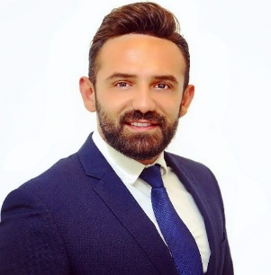 SAMER KANSOU

EXPERIENCE

Sales Manager (Cerviced) :01/01/2018-01/11/2018
Gather databases and identify specific target audiences that would have potential interest in serviced offices
Source potential Investors and establish/ maintain a good working relationship.
Build corporate relationships to increase awareness and acquire clients.
Create marketing campaigns to maintain awareness of all current and upcoming properties.
Inform current and potential clients of upcoming offers...
Discovering and pursuing new sales prospects, meeting with brokers and potential clients.

Senior sales consultant
BXP (BROKERS XP):2016/2017
Location: Beirut/Lebanon
Company Industry: real estate
Job Role: Real estate agent.
Look for clientele interested in buying or renting assets such as apartments, studios and expand the business strategy.
Interior designer and sales agent
Kitchen design: 2014/2016
Location: Beirut/Lebanon
Company Industry: real estate
Job Role: Real estate agent.
Work on several things such as twenty twenty program in order to design kitchens and get clients to the showroom (show them around) and expand the sales strategy
Sales and customer service manager
At Arcom Al Moussawi
Location: Lebanon / Beirut
Company Industry: Sales
Job Role: Customer Service and sales man
2012 till 2014: (2 years)
I started as sales man as I made a record in sales in outdoor furniture, Grass ceramic , bathroom and sanitary Mosaic . The sales experience was with the following kind of products: (Cleopatra, Refine, Sichis mosaic, Baldocer, Lybrand vondom etc…) and create ideas to promote our products.
And referring to my performance I got my promotion as Manager of customer service and call Centre. Responsibility to reduce the total of customers’ call by meeting them and solve their problems, manage the department by a system linked between all the other departments, train the employees to provide the customer best customer service.

