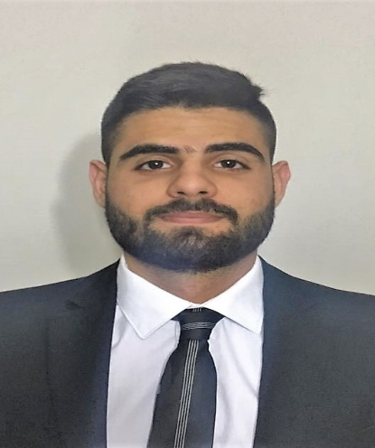
CURRICULUM VITAE

Objective

Seeking a job opportunity that exposes me to different kinds of experience that provides me with Career Satisfaction and Self-Development in order to help me accomplish my personal as well as Organizational goals.

Personal Details

Full Name : | Mohammed Ahmad Mouslemani
Gender : | Male
Nationality : | Lebanese
Date Of Birth : | September 18th , 1996
Marital Status : | Single
Address : | Beirut , Tariq Aljadida , Salam building- 1st floor
Telephone : | 01319018 | Mobile : 78836254
E-Mail : | mohammedmouslemani1996@hotmail.com
Languages known: | First language : English  Second language : French , Arabic
Health : | Very Good
Interests : | Reading , Sports , Travelling , Hiking
Occupation : | Fresh Graduate , Graduated on August 2018

Educational Background
2018-Present | Lebanese International University-Beirut Lebanon  Master in Business Administration ( Thesis in Management )  Start Date : 1th October 11, 2018  Year of Graduation : Fall 2021
2015-2018 | Lebanese International University – Beirut Lebanon  Bachelor of Marketing  Year of Graduation : August 2018  GPA: 3.19/4
2013-2014 | Roman Ridge School / Cambridge International Examinations – Accra Ghana  GCE AS Levels – General Certificate of Education Advanced Subsidiary Level
2011-2012 | Roman Ridge School /Cambridge International Examinations – Accra Ghana  IGCSE- International General Certificate of Secondary Education

1th August 2018 – 8th October 2018 | Makhzoumi Foundation - NGO  Marketing and Communication Intern  - Data Analysis and Marketing plan for MF Vocational Training Department  - Marketing and Communication Plan for a Diet Campaign (Using all types of Advertisement being from Social Media to Outdoor)  - 5-Index Data Entry  - Marketing and Communication Plan World Diabetes Campaign  - Helping out the Marketing and Communication Posts on Social Media ( Using Photoshop and Canva)
Work Experience
Communication Skills: Good in Verbal and Non-Verbal Communication, Good in Listening to figure out Problems Facing and more
Computer Skills: Microsoft office (Excel, Word, PowerPoint), Adobe Photoshop, Social Media Ads
Time Management
Team Work: Working with Different People
Self-Motivating: I learn how to motivate myself and others in hard times, to proceed with the Organizational goals and achieve them within the time frame needed.

Skills
Voluntary experience
2011-2012 | The African Regent Hotel – Accra Ghana  Student work experience day a tour of the African Regent Hotel and how it’s operating within a day.  We gathered Information of different departments and the standards of a four star Hotel:  - Marketing Department  - Economics Department  - Reception  - Cuisine  - Laundry and more …
2008-2009 | Eco-Bank –Accra Ghana  Student work experience day a tour of how the bank is operated in a day  We worked as student to have an idea of :  - Teller work  - Floor Customer Service  - Vault Money Count

References

Available Upon Request

