Name : Sireen Bassam Youssef
E-mail: sireen-youssef@hotmail.com
Mobile Phone : +961 79 196939
Date of Birth: April 18, 1997
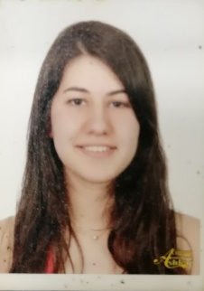

Objective:
To enhance my educational and professional skills in a stable and dynamic workplace.
Education:
2016 – Present Modern University for Business and Sciences
Bachelors in Business Administration
2015 – 2016 Lebanese University – Faculty of Law
International Law
2015 Shouf National College
Lebanese Baccalaureate II in Socio Economics
Experience:

House of Pines Market
Accountant

October 2017 - Present

Key Tasks and Responsibilities:
- Managing daily sales and daily account balances and reconciliations
- Planning and supervising inventory counts
- Supervising employees
- Managing deliveries and distribution including reconciliations
- Recording and reconciling received goods and purchase orders.

Trainings and CPE:
“Master Curriculum, Capacity Building and Network Development in Traffic Safety in Egypt Jordan and Lebanon” by Erasmus+ Programme of the European Union
Computer Skills:
- Microsoft Office (excellent knowledge of Excel, Word, & Power Point)
Personal Skills and Attributes
- Ability to work under pressure
- Analytical skills
- Cooperation
- Confidentiality
- High communication and interpersonal skills
- High motivation
- Time management
Languages:
Excellent written and spoken skills in English and Arabic. Fair written and spoken skills in French.
Volunteering:
May 2018
Injaz Innovation Camp
Observer in LADE- Lebanese Associations for Democratic Elections
2014 – 2017
Paramedic - Lebanese Red Cross
2016
Youth Speaker Programme – Saint Joseph University
References:
Available upon request

