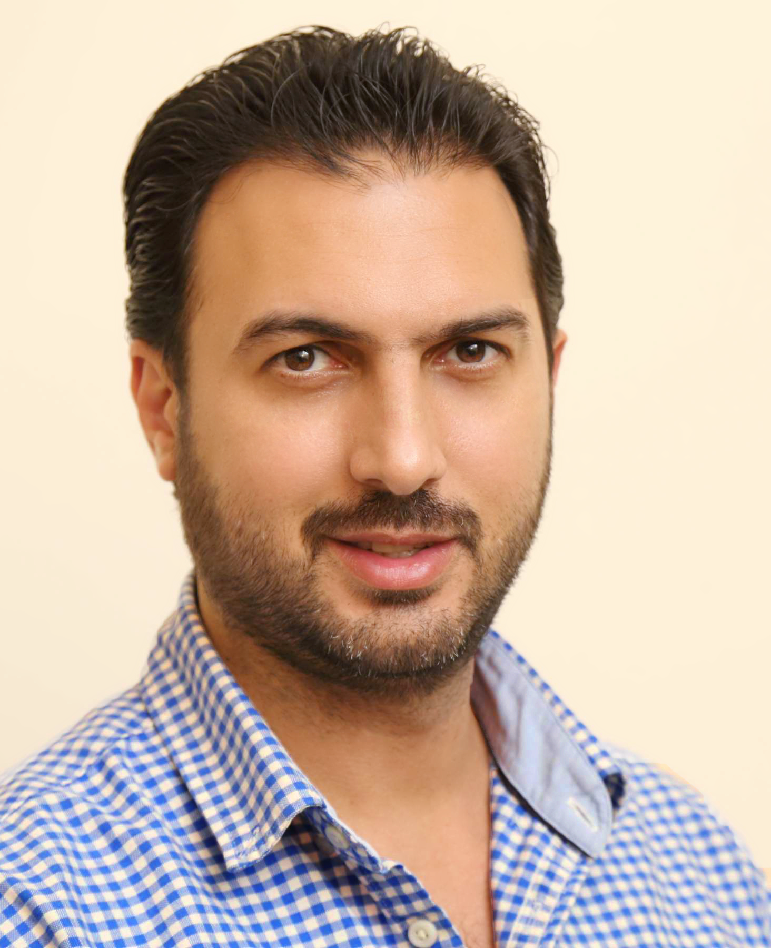

Hassan Raychouni
Mobile: 0096178814900
Email: Hassan_raychouni@yahoo.com
Instagram: hassanraychouni1

Personal Information
Nationality: Lebanese
Date of Birth: 07 February 1976
Gender: Male
Marital status: Married
Others: Holding UAE driving license
Objective
Creative photographer, passionate about photography of many different sorts and variations, acquired more than twenty years professional photography experience working on exceptional inspiring projects with intuitive and innovative styles. Secure the position of a digital photographer and utilize my photography skills to capture photographs. To get an opportunity where I can challenge my abilities to the fullest level and gain expertise in this field.

Skills
- Excellent personal communications skills.
- Excellent technical and photographic skills.
- Excellent Expertise in Photoshop editing, image manipulation, and image restoration.
- Excellent interpersonal, persuasive and communication skills.
- Punctual in meeting deadlines.
- Self-motivated and comfortable in working and communicating with people of diverse backgrounds.
- Self-reliant, organized and able to multi-tasking.
- The ability to propose solutions process.
- The ability to create and innovate.
- keep abreast of new technologies in the field of photography and new media.

Work Experience

- Experience in the field of professional photography journalist and private (1991-2006)
- studios imaging management
- Framing subject matter and background in lens to capture desired image, focusing camera and adjusted settings based on lighting, subject material, distance, and film speed, selecting and assembling equipment and required background properties according to subject, materials, and conditions, directing activities of workers assisting in setting up photographic, and arranging subject material in desired position.
- Prepare records and reports, such as client fulfillment orders and detailed client listings.
- Analyze operating practices and procedures to create and revise existing methods.

- Senior Photographer in Dar Al Sada of Press and Publication and Distribution (2006-2016).

- Contributed to the significant growth of the business by developing reputation for quality imagery.
- Excellent knowledge in defining themes and concept for photography and graphic design, undertaking or supervising photography.
- Experimented with taking photos with diverse lighting effects to produce unique and creative photographs.
- An excellent communicator, with tact and diplomacy skills, routinely deals with problems or even crisis situations.
- Able to perform all administrative tasks to ensure smooth and efficient operations, very skilled at preparing and distributing materials.
- Using a range of digital or standard cameras to take pictures.
- Using lighting equipment.
- Visiting different locations.
- Preparing studios or locations.
- Developing and editing pictures in preparation for publication in many different areas of photography to specialize in, including: Journalism, Portrait, Documentary, Fashion, Wedding, decor and many others.

Qualification
Vocational in the electronic Major.

Languages
- Fluent in Arabic (native language).
- Good in English.

